Science  Electricity  Voltage  Function of components in a circuit  Component symbols  Light  Light travels in straight lines  Reflection  Light sources  Shadows | Music  Composing and performing a leavers song  Identify and evaluate the musical features of a song.  Contribute ideas to their group, suggesting how lines 3 and 4 could rhyme as well as the verse in lines 1 and 4 and 5 and 8.  Fit an existing melody over a four-chord backing track.  Create a melody that fits both the lyrics and the four-chord backing track of the chorus, using tuned percussion instruments.  Record melodies using letter notation  Perform the leavers’ song with confidence. | Spanish  Animals  Pets – colours, pets we like / don’t like  Animals in the zoo / wild  Describe animals using adjectives
History  Ancient Civilisations  - Identify where and when ancient civilisations began  - To compare daily lives in different civilisations  - Compare architecture, trade, writing systems  - Look at inventions across the civilisations | Brackenwood Junior School    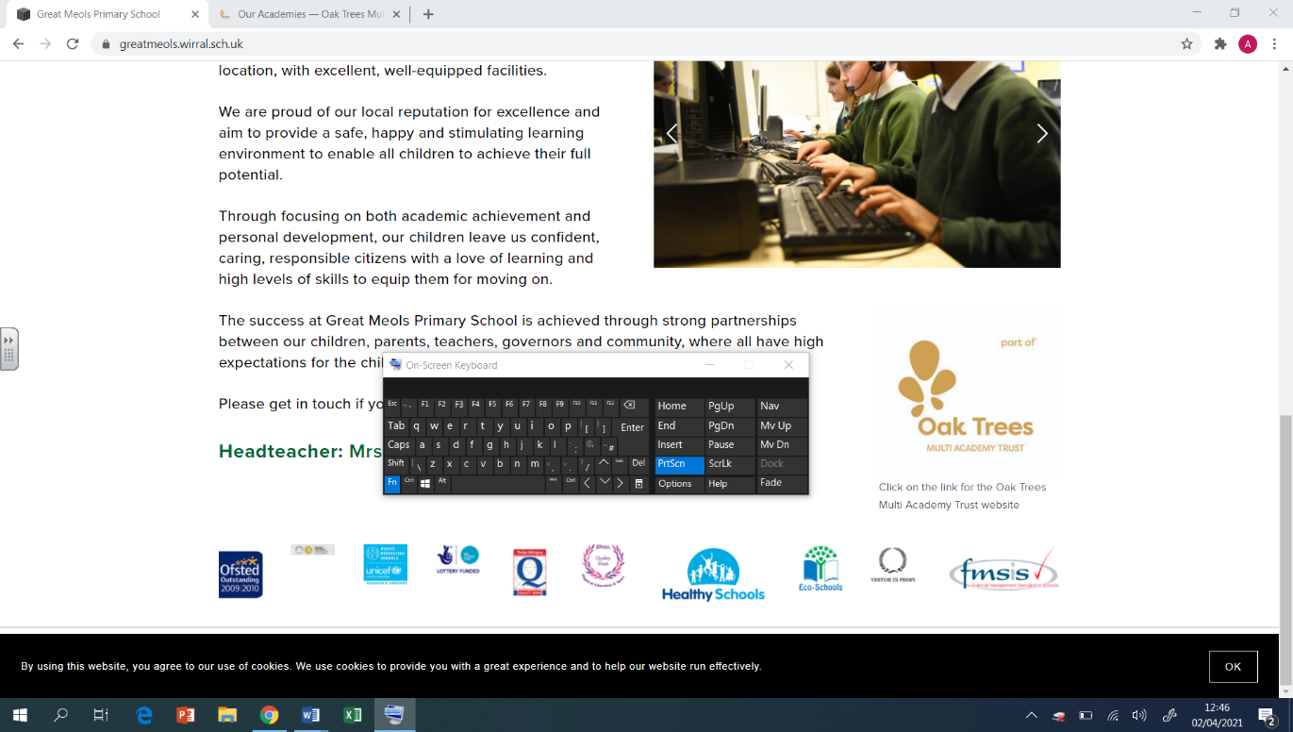  Y6  Summer Overview | PE  Ultimate Frisbee  effective catching techniques, throwing accuracy, tactics  Athletics  Sprinting technique, long-distance running strategies, assess and feedback on technique  Orienteering  Problem solving, communication, teamwork  Rounders  fielding tactics, spacial awareness, communication, batting technique
Geography  Interconnectivity  To locate UK, China and UAE on a map and identify land borders  To plan relevant questions for a fieldwork study  To explore transportation links between different countries  To investigate the trends and patterns of a country’s economy and population  To identify causes and solutions of air pollution in the UAE, China and UK  , | DT  Digital World: Navigating the World  - To write a design brief and criteria based on a client request.  - To write a program to include multiple functions as part of a navigation device.  - To develop a sustainable product concept.  - To develop 3D CAD skills to produce a virtual model.  - To present a pitch to ‘sell’ the product to a specified client.  Electrical Systems: Steady Hand Game  - To design a steady hand game.  - To construct a stable base.  - To assemble electronics and complete their electronic game. | RE  The Natural World  - What do different faiths say about how the world was created?  - What are some similarities between the creation stories?  - What are the scientific and non-religious views on how Earth was created?  - What is stewardship?  - What can faith members do to care for the world and the environment?  What influences people to look after the natural world?
Computing  3D modelling  Introduction to 3D modelling, modifying 3D objects, make your own name badge, making a desk tidy, planning a 3D model, make your own 3D model  Sensing  The micro:bit, sensing inputs, finding your way, designing a step counter, making a step counter | Art  Artist- Phil Dean (The Shoreditch sketcher)  Drawing  Identify artists who have worked in a similar way to their own work  Demonstrate a wide variety of ways to make marks with wet&dry materials.  Manipulate and experiment with the elements of art: line, tone, pattern, textures, form, space, colour and shape.  3D Form  Describe the different qualities involved in modelling, sculpture and construction.  Develop skills working in 3D  Make a models and develop, making alterations to create a final piece. | PSHE  PSHE  Pupils who are secure will be able to:  - Understand that there can be a range of feelings related to money and the desire to spend and save.  - Understand their responsibilities in keeping money safe in the bank.  - Understand what gambling is and some risks associated with it.  - Understand that there are a range of jobs that people can do, what some of these jobs are and what is required for some jobs.  - Understand that there are different routes into careers.

