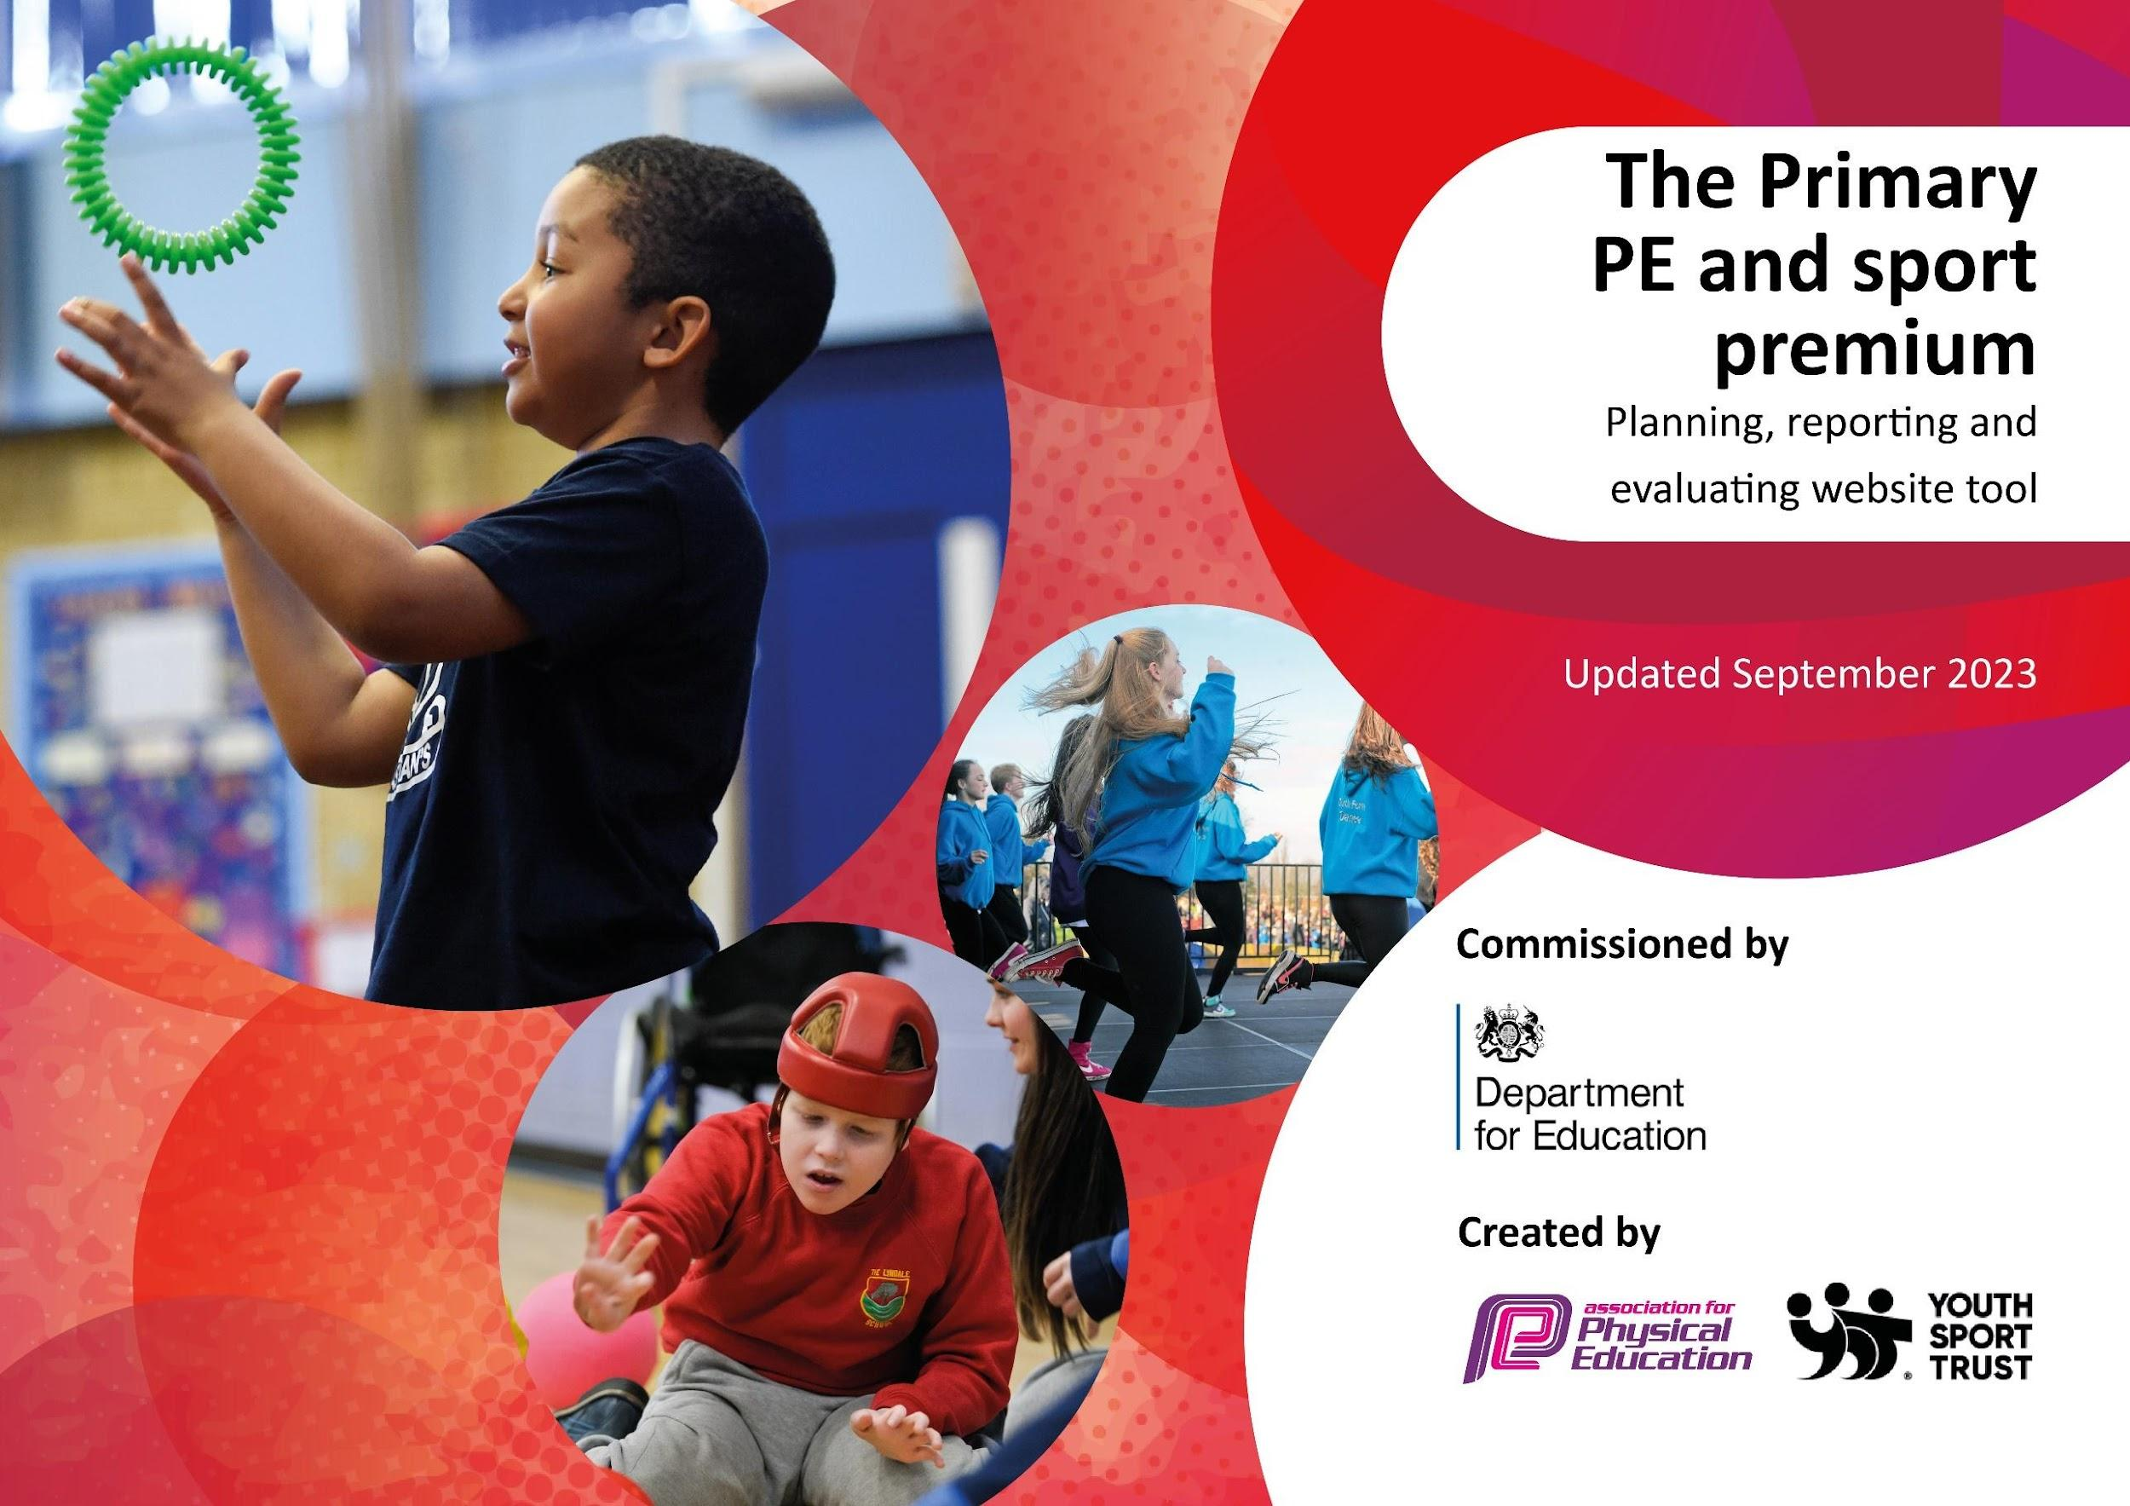

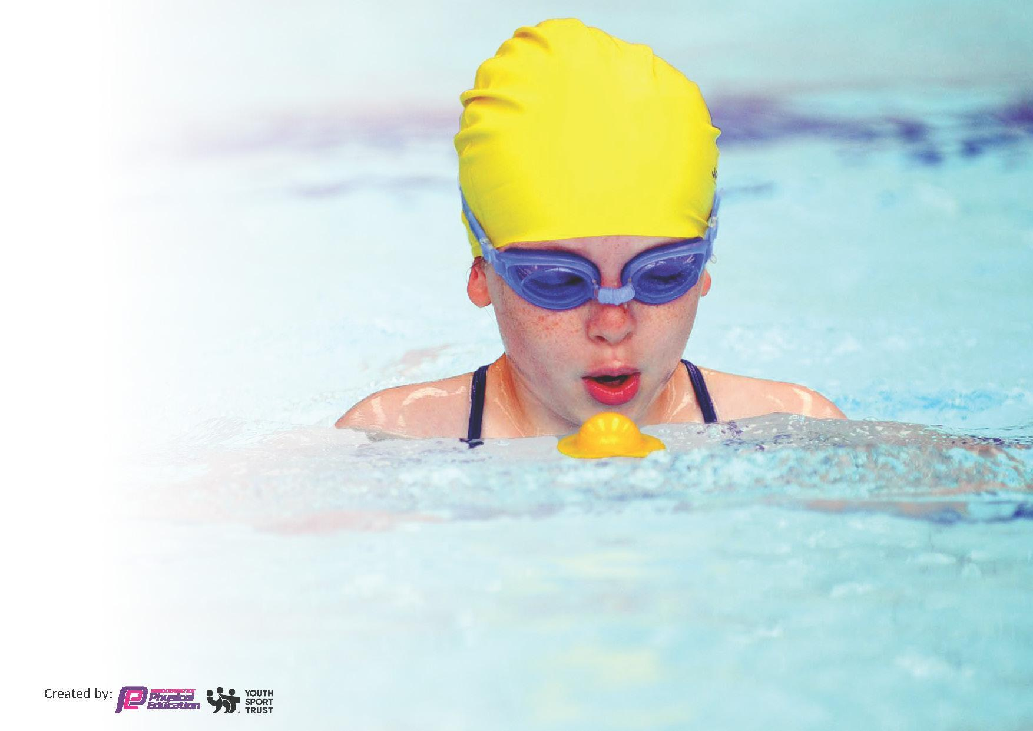
This template can be used for multiple purposes:
by:
- It enables schools to effectively plan their use of the Primary PE and sport premium
- It helps schools to meet the requirements (as set out in guidance) to publish information on their Primary PE and sport premium
- It will be an effective document to support Ofsted inspections enabling schools to evidence progress in Physical Education (PE) and evidence swimming attainment, which forms part of the PE National Curriculum. We would recommend schools consider
the Intent, Implementation and Impact of any spend, as examined within the Education Inspection Framework.

It is important that your grant is used effectively and based on school need.

Schools must use the funding to make additional and sustainable
improvements to the quality of the PE, School Sport and Physical Activity (PESSPA)
they offer. This means that you should use the Primary PE and sport premium to:

- Build capacity and capability within the school to ensure that improvements made now will benefit pupils joining the school in future years
- Develop or add to the PESSPA activities that your school already offers.

The Primary PE and sport premium should not be used to fund capital spend projects; the school’s core budget should fund these. Further detail on capital expenditure can be found in the updated Primary PE and sport premium guidance.

The Primary PE and sport premium guidance, outlines 5 key priorities that funding should be used towards. It is not
necessary that spending has to meet all the key priorities, you should select the priorities that you aim to use any funding towards.

Although completing this template is not a requirement for schools, schools are required to publish details of how they spend this funding. Schools must also outline what the impact this funding has had on pupils’ PE and sport participation and attainment and how any spending will be sustainable in the future. All funding must be spent by 31st July 2024.

The Department for Education has worked closely with the Association for Physical Education (afPE) and the Youth Sport Trust (YST) to develop this template and encourages schools to use it. This template is an effective way of meeting the reporting requirements of the Primary PE and sport premium.
Review of last year’s spend and key achievements (2022/2023)

We recommend you start by reflecting on the impact of current provision and reviewing your previous spend.

Activity/Action | Impact | Comments
Increased participation in walk to school scheme  Implementing activities to gain the School Games Mark  Staff have accessed CPD from Co-Op Academy  New and Improved LTP and MTP  Increased amount of extracurricular activity | Pupil voice demonstrates improved enjoyment, improved levels of fitness and children who are ready to learn. Observations show a calmer start to the day and children more alert.  Increased competition  Increased participation in a wide range of competitions and sports festivals eg Futsal, Quick Cricket, Pentathlon, Quad Kids)  Staff now have improved skills through co-coaching strategies. Staff also attended targeted CPD for areas of development. This includes SEN in sports and gymnastics CPD. This is reflected in a before/after questionnaire along with targets achieved from lead teacher.  Collaborative work with schools across the MAT trust and our partner secondary school to develop and improve our Long Term to ensure full coverage that meets the main aims of the NC. Opportunities to retrieve key skills and knowledge was also embedded into lessons.  The range and number of clubs available to all year groups increased over the year. Record keeping demonstrates that over 60% of our children attended clubs in a year. | Gold Schools Mark achieved

Key priorities and Planning
This planning template will allow schools to accurately plan their spending.
£18,510

Action – what are you planning to do | Who does this action impact? | Key indicator to meet | Impacts and how sustainability will be achieved? | Cost linked to the action
To introduce a club for non-active children | This will impact staff who lead the club, the children who attend and midday assistant arrangements | Key Indicator 1-To analyse the club registers and identify children who have not attended an active club by February 2024.  Key indicator 2 -The engagement of all pupils in regular physical activity – the Chief Medical Officer guidelines recommend that all children and young people aged 5 to 18 engage in at least 60 minutes of physical activity per day, of which 30 minutes should be in school.  Key indicator 4: Broader experience of a range of sports and activities offered to all pupils. | More pupils meeting their daily physical activity goal, more pupils encouraged to take part in PE and Sport Activities. | £1140 costs for additional coaches to support lunchtime sessions.

To provide consistent CPD for all teaching staff  To provide a wide range of lunchtime and afternoon clubs termly  Provide additional swimming sessions for all Key Stage Two pupils to develop fundamental swimming skills earlier and therefore further increase percentage of Y6 children achieving NC level.  Attend a wide variety of competitions throughout the school year to give opportunities for maximum children to participate.  Hold an inclusive sports festival (Summer term) including a wide variety of sports and rewards for all children.  Investment in Sports equipment to facilitate PE curriculum | Primary generalist teachers.  Sports Coach  Year 6 Autumn block (5 sessions of 60 minutes per class)  Year 5 Spring block (5 sessions of 60 minutes per class)  Year 4 Summer block (5 sessions of 30 minutes per class)  Year 3 Summer block (5 sessions of 30 minutes per class)  Engage with local secondary school competitions (e.g. South Wirral High School).  Engage with Wirral School Games Level 2 and 3 (where possible) competitions.  Engage with Wirral Cross Country events.  Purchase medals and stickers to promote Spirit of the Games during festival.  Teachers and Staff | Key Indicator 1: Increased confidence, knowledge, and skills of all staff in teaching PE and sport.  Key indicator 5: Increased participation in sport.  Key indicator 4: Broader experience of a range of sports and activities offered to all pupils  Key indicator 5: Increased participation in competitive sport.  Key indicator 4: Broader experience of a range of sports and activities offered to all pupils  Key indicator 5: Increased participation in competitive sport.  Key indicator 4: Broader experience of a range of sports and activities offered to all pupils | Primary teachers more confident to deliver effective PE supporting pupils to undertake extra activities inside and outside of school, including teaching water safety and swimming and as a result improved % of pupil’s attainment in PE.  More pupils meeting their daily physical activity goal, more pupils encouraged to take part in Sport Activities.  Wake up and Shake Up 3 days a week for all year groups with increased participation  Year 6 Sports Leaders  Year 5 Sports Ambassadors  KC runs wake up and shake up  Path used daily by each class weather permitting  Afterschool sports clubs offered 5 days a week by teacher and/or sports coach  Better quality of PE teaching and learning in all year groups. | £2000  £3040  Wake and shake Coach - £1000  £687.50 x 6 = £4125  Coach £3600  Total - £7725  £1800  £2000

Key achievements 2023-2024
This template will be completed at the end of the academic year and will showcase the key achievements schools have made with their Primary PE and sport premium spending.

Activity/Action | Impact | Comments

Swimming Data
Meeting National Curriculum requirements for swimming and water safety.
Priority should always be given to ensuring that pupils can perform safe self-rescue even if they do not fully meet the first two requirements of the National Curriculum programme of study

Question | Stats: | Further context  Relative to local challenges
What percentage of your current Year 6 cohort can swim competently, confidently and proficiently over a distance of at least 25 metres? | 6LW  6D | Pupils took part in swimming lessons over a  week at a local pool as Year 3, 4 and 5s.
What percentage of your current Year 6 cohort can use a range of strokes effectively [for example, front crawl, backstroke, and breaststroke]? | 6LW  6D

What percentage of your current Year 6 cohort are able to perform safe self-rescue in different water-based situations? | 6LW  6D
If your schools swimming data is below national expectation, you can choose to use the Primary PE and sport premium to provide additional top-up sessions for those pupils that did not meet National Curriculum  requirements after the completion of core lessons. Have you done this? | Yes | Pupils currently in Year 6 who can not swim 25m  competently, confidently and proficiently after  their year group attends will be able to access  lessons later in the year.
Have you provided CPD to improve the knowledge and confidence of staff to be able to teach swimming and water safety? | No | Swimming is taught by qualified swimming teachers  at Calady Swimming Pool.

Signed off by:

Head Teacher: | Miss R Fry
Subject Leader or the individual responsible for the Primary PE and sport premium: | Mr Williams PE Lead
Governor: | Morag Kophamel
Date: | September 2023

