Brackenwood Junior School
Part of Oak Trees MAT

SEND Information Report 2022-23
SENDCo: Miss Fry and Ms Balmer 🕿0151 608 3001
Contributing to the Wirral Local Authority Local Offer

 | Article 12  Every child has the right to say what they think in all matters affecting them, and to have their views taken seriously. | Article 23  A child with a disability has the right to live a full and decent life in conditions that promote dignity, independence and an active role in the community. Governments must do all they can to provide free care and assistance to children with a disability | Article 29  Education must develop every child’s personality, talents and abilities to the full. It must encourage the child’s respect for human rights, as well as respect for their parents, their own and other cultures, and the environment.
Contents:
Please use this coloured contents guide to help to lead you through this document.
What is a Special Educational Need and Disability?
What do I do if I think my child has Special Educational Needs (SEND)?
Who can support my child in school with Special Educational Needs (SEND)?
How could my child get help in school?
How do we support children across the school?
How can you be supported as a parent of a child with additional needs?
How can your child be supported during transition in school?
What specialist services and expertise are available in this school?

What is a Special Educational Need and Disability?
The Children and Families Act 2014 clause 20 says that:
- A child or young person has special educational needs if he or she has a learning difficulty or disability which calls for special educational provision to be made for him or her.
- A child of compulsory school age or a young person has a learning difficulty or disability if he or she-
- Has a significantly greater difficulty in learning than the majority of others of the same age, or
- Has a disability which prevents or hinders him or her from making use of facilities of a kind generally provided for others of the same age in mainstream schools or mainstream post 16 institutions.
- A child under compulsory school age has a learning difficulty or disability if he or she is likely to be within subsection2. When of a compulsory school age (or would be likely, if no special education provision were made).
- A child or young person does not have a learning difficulty or disability solely because of the language (or form of language) which is or has been spoken at home.
Looked after children (LAC) with SEND: We consult with the SENDCo and the designated teacher for LAC as appropriate for personalised support. We also liaise with the allocated social worker to ensure all agencies are working collaboratively to develop an appropriate support package for each child.
SENDCO - Mrs Balmer
Designated teacher for LAC – Mrs Balmer

Inclusion statement – Achieving Excellence Together
RESPECT COLLABORATE INSPIRE
Together we support and meet the individual needs of all pupils in each of our schools. Effective learning opportunities allow pupils to overcome individual barriers and encourage them to strive for their best to achieve excellence for all.
We ensure our schools are open and welcoming communities and embrace all social, cultural and educational backgrounds and needs. We actively seek and value the views and aspirations of all parents, carers and children to strengthen our curriculum and provision. We are committed to working closely with all agencies to achieve the best outcomes for our children.
All children will have a sense that they belong in all areas of school life. Opportunities will be provided to fulfil potential through extending life experiences which encourage imagination and fun.
We are continually evolving our practice with an open-minded approach and a willingness to try and to implement new ideas. Our practice is based on the latest evidence and research in providing effective education for all.

School context
There are 252 children on roll. There are currently 52 on the SEND register – 20%. This represents the primary need of those children.
C&L – 15 chn
C&I – 19 chn
P&S – 1 child
SEMH – 17 chn

This information is shared with the Local Authority on a termly basis.
At Brackenwood, we currently provide additional support and/or different provision for a range of needs across the four areas.
Four Areas of Need | Cognition and Learning | Communication and Interaction | Physical and Sensory Needs | Social, Emotional and Mental Health
Brackenwood’s current needs of the children in our school | Specific learning difficulties such as dyspraxia and dyslexia and working memory and processing skills | Speech, Language and Communication needs, including ASC/ASD | Vision, Hearing and Physical needs | ADGD  Emotional and Behavioural needs

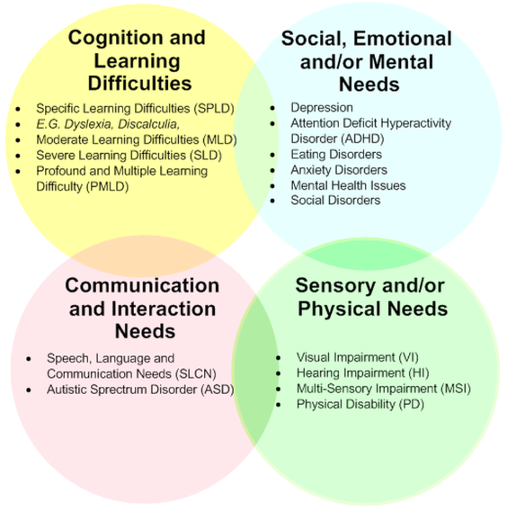
Examples within each area of need

What do I do if I think my child has Special Educational Needs?
Who to contact | - If you have concerns about your child’s progress you could speak to your child’s class teacher.  - You can also speak to the SENDCo.  - The Head teacher can be contacted if you have concerns about how your child’s SEND is being managed.
School response | - Where there are concerns about your child’s progress or learning in response to Quality First Teaching curriculum, the teacher may raise this with the SENDCo.  - The school has termly pupil progress meetings to monitor the progress of all pupils in relation to Quality First Teaching.  - The teacher will monitor throughout the curriculum. These are some of the concerns they will monitor:  Cognition and Learning - Data at the end of term, if it is slower than expected progress in Reading, Writing and Maths - Difficulties working at an age-related standard - Letter formation, number and letter reversals - Difficulties retaining information and processing - Working Memory concerns  Communication and Language - Speech sound pronunciation difficulties - Stammers and stutters - Difficulties in understanding language for their age - Difficulties with communication and understanding of language and social cues - Difficulties interacting with other children through play  Physical and Sensory - Pencil control and grip concerns - Difficulties using tools such as scissors - Trips, falls, bumps into things frequently - Sensory concerns – difficulties tolerating noise, touching things - Vision and hearing concerns - Difficulties accessing PE sessions – lack of spatial awareness, coordination and balance difficulties  Social, Emotional and Mental Health - - Attention difficulties - Concentration is limited / easily distracted/ struggle to listen and sit still - Behaviour concerns - meltdowns, impulsive, challenging - Anxiety -Low self-esteem and self-confidence - Sleep concerns  If there are further concerns about your child’s learning, the school will discuss this with you and there will be opportunities to discuss:  - Any concerns you may have as a parent/carer.  - Plans for any additional support your child may receive.  - Referrals to outside professionals to support your child’s learning.  - How we will work together, to support your child at home and school.  School follow the ‘Assess Plan Do Review Cycle’. Parents and children (where appropriate) will be involved at all stages:  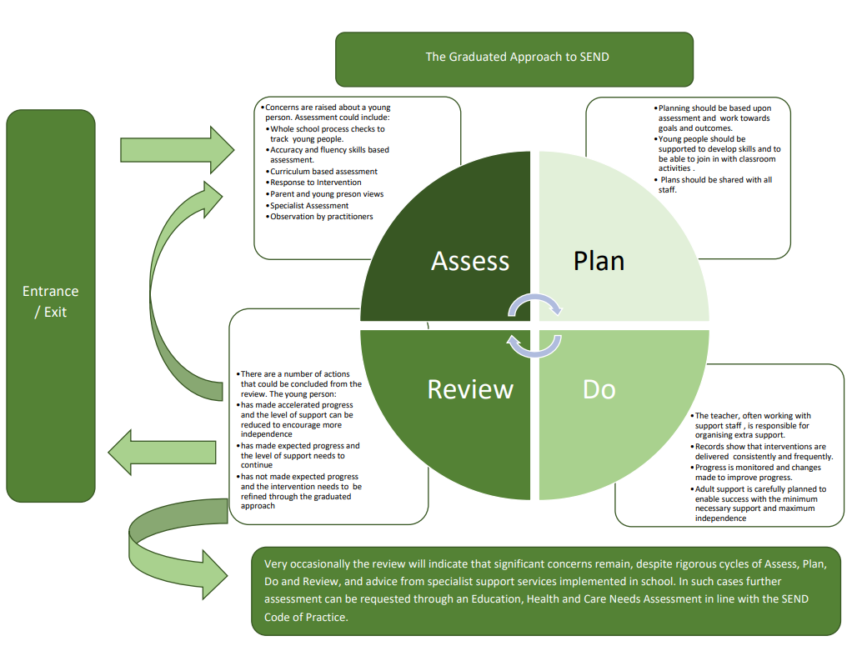

An overview of our school provision
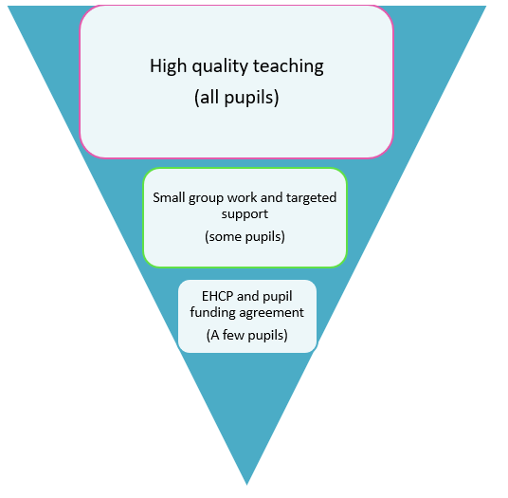
Number of pupils in our school: 246

50 of our pupils, 20% have SEND.

5 of our pupils, 2% have an EHCP or a pupil funding agreements.

Who can support my child in school with Special Educational Needs (SEND)?
People | Summary of responsibilities.
Class teacher | He/She is responsible for:  - Ensuring that all children have access to Quality First Teaching across all curriculum areas and that the curriculum is adapted/ modified to meet children’s needs.  - Develop the curriculum so it is coherent, progressive, engaging, broad and balanced and knowledge rich.  - Checking on the progress of your child and identifying, planning for and delivering any additional help your child may need (this could be targeted work, additional support, adapting resources etc) and talking about this with the SENDCo as necessary.  - Writing Additional Support Plans and sharing with parents on a termly basis.  - Personalised teaching and learning for your child as identified on the school’s provision map.  - Ensuring that all members of staff working with your child in school are aware of your child’s individual needs and any specific adjustments/ modifications which need to be made to enable them to be included and make progress in the classroom.  - Ensuring that all staff working with your child in school are supported in delivering the planned work/programme for your child, so they can achieve the best possible progress. This may involve the use of additional adults, outside specialist help and/or specially planned work or resources such as writing frames, small group work, 1:1 support or use of equipment, including the use of ICT.  - Ensuring that the school’s SEND practice is followed in their classroom and for all the pupils they teach with any SEND.  You can contact the class teacher via the school office for an appointment or at the beginning or end of the school day to speak informally or via the school email address. (senco@brackenwood-junior.wirral.sch.uk or call 0151 608 3001)
Curriculum Subject Leads | He/ she is responsible for:  - Planning long-term plans and progression maps to ensure all pupils are developing knowledge and skills that build on previous learning and prepares them for future learning to impact long-term memory.  - Working with the SENDCo to support staff in making modifications to their subject curriculum for individual children.  - Ensuring that progress is made for all children, including SEND, in their subject area.
Special Educational Needs Co-ordinator (SENDCo)  Miss R Fry and Ms Balmer | She is responsible for and will use her best endeavour to:  - Coordinate all the support for children with special educational needs (SEND) and developing the school’s SEND practice to make sure all children get a consistent, high quality response to meeting their needs in school.  - Ensure you are involved in supporting your child’s learning and keeping you informed about the support your child is getting.  - Liaise with all the other people who may be coming into school to help support your child’s learning e.g. Speech and Language Therapist, Educational Psychologist.  - Update the school’s SEND register, (a system for ensuring all the SEND needs of pupils in this school are known and understood) and checking/maintaining your child’s records of progress and needs.  - Supporting requests for additional funding from Wirral Local Authority.  - Provide specialist support for teachers and support staff.  - Support your child’s class teacher with creating and reviewing ‘Assess Plan Do and Review’ plans, which identify actions put in place to meet targets.  - Organise training for staff.  - Liaise with cluster SENDCo’s to ensure consistency of approach and practice.  - Monitor, track and analyse progress and attainment of SEND pupils.  - Liaise and ensure smooth transition between educational phases.  - Co-ordinate SEND interventions, through provision mapping.  - The day to day management of all aspects of the school, including support for children with SEND.  - Entrusting the daily responsibility for SEND to the SENDCo and class teachers and overseeing effectiveness of this.  - Ensuring the Governing Body is kept up to date about any issue relating to SEND and meeting regularly with the SEND Governor to discuss the provision for children with SEND.  Miss R Fry and Ms Balmer (SENDCos) can be contacted by the school office for an appointment.
Headteacher  Mrs C Arnold | They are responsible for and will use his best endeavour to:  - Oversee the effectiveness of provision for children with SEND.  - Develop the school’s SEND practice to make sure all children get a consistent, high quality response to meeting his or her needs in school.  - Monitor, track and analyse the progress and attainment of all children.  - Support the teaching staff and SENDCo.  - Ensure effective and efficient, use of human, environmental and financial resources  Mrs C Arnold can be contacted by the school office for an appointment.
SEND Governor  Mrs H Lubbe | She is responsible for:  - Making sure that the school has an up to date SEND Policy and/or SEND Information Report.  - Making sure that the school has appropriate provision and has made necessary adaptations to meet the needs of all children in the school.  - Making visits to understand and monitor the support given to children with SEND in the school and being part of the process to ensure all SEND children achieve their potential in school.  - Meeting with the SENDCo regularly to discuss provision for the children with SEND.  Mrs H Lubbe can be contacted by the school office for an appointment.

How could my child get help in school?
At Brackenwood Junior School, we offer a graduated approach to Special Educational Needs and Disabilities so that a child will initially be supported by high quality teaching.
Types of support | What would this mean for your child? | Who receives this support?
Class teacher  Quality First Teaching | All children receive Quality First Teaching with teacher making reasonable adjustments to children’s learning in the classroom and using different ways of teaching so that your child is fully involved in class.  This may involve, but is not exclusive to:  Cognition and Leaning Visual timetables in class, now and next cards, talk partner work, working walls, number lines, alphabet mats, writing frames, concrete maths resources, use of technology  Communication and Language Social stories, using a TA to check understanding and repeat instructions  Physical and Sensory Enlarging resources, writing slopes, pencil grips, alternative scissors, ear defenders, rest breaks, sensory resources, handwriting support, fiddle toys  Social, Emotional and Mental Health Using sand timers to complete work, brain breaks, fiddle toys, buddy up with a partner, writing worries in a book  Ensuring that the teacher has the highest possible expectation for your child and all pupils in their class.  Ensuring that all teaching is based on building on what your child already knows, can do and can understand.  Putting in place specific strategies (which may be suggested by the SENDCo or outside staff) to support your child’s learning.  Your child’s progress is continually monitored by his/her class teacher.  Attendance, engagement in learning and behaviour are also monitored.  His/her progress is reviewed formally every term through pupil progress meetings with the Senior Lead Team.  You will be informed of your child’s progress and attainment at Parent/Carers’ evenings in the Autumn and Spring terms and will receive a school report at the end of the school year. | All children in school.
Assessment | Assessment cycle:  End of Autumn Term End of Spring Term End of Summer Term  End of term assessments Reading, Maths, SPaG Teacher assessed writing Reading ages Review of SEN support plans (ASPs), new ones written End of term assessments Reading, Maths, SPaG Teacher assessed writing Reading ages Review of SEN support plans (ASPs), new ones written End of term assessments Reading, Maths, SPaG Teacher assessed writing Reading ages Review of SEN support plans (ASPs), new ones written  Children with SEND have additional layers of assessment:  -Intervention monitor and assessment  -Outside agencies assessments  -EHCP and PFA reviews  Year 3 children are baselined during Autumn 1 to inform support and to help with monitoring progress. Phonic screening checks are also undertaken with children who failed in Year 1 and 2.  SATs – External end of Key Stage 2 tests are sat by Year 6 during the Spring Term. | All children in school
Specific interventions e.g. groups or 1:1 which may be:  ∙Run in the classroom or outside.  ∙Run by a teacher or teaching assistant. | Children may require targeted support from school-based staff, or sometimes your child may need specialist support from a professional from an outside agency e.g. Speech and Language.  Your child’s class teacher or the SENDCO will have monitored your child’s progress and will have planned specific group work to help close the gap between your child’s achievement and that of his or her peers.  A TA will run these small group sessions using the teacher’s targets or a recommended programme, such as: 1:1 reading; Read, Write, Inc; social skills support, handwriting.  Each child’s progress is evaluated regularly, before and after the period of intervention. | Any child who has been identified as having specific gaps in his or her understanding of a subject/area of learning.  Children whose learning needs require specialist support and advice in addition to the support already received in school.  The most important point is that the additional provision depends on the needs of the child.
SEND support | Children in this group will receive some of the interventions outlined above and will also be on the SEND register. If this is the case, they will have an ASP (Additional Support Plan) written for them to help monitor the support they are receiving both inside and outside the classroom. Your child may also have a One Page Profile which outlines brief information on how your child learns and what is the best way to support them.  If the class teacher and SENDCO feel that sufficient progress is not being made then a child may progress to more specialist advice and support from outside agencies such as Educational psychologist, SENAAT, CAMHS, Gilbrook Outreach, ADHD Foundation, ASC team. | Children who are on the SEND register.
Children with Educational, Health Care Plans and Pupil Funding Agreements | The LA local offer: The local offer website sets out what services, support and advice are available for children in Wirral if they have SEND.  The school, or you, can request that the Local Authority carry out a statutory assessment of your child’s needs. This is a legal process and you can find more detail about this in the Local Offer on the Wirral Borough Council website: www.schools.wirral.gov.uk  After the school have sent in the request to the Local Authority it will be decided whether your child’s needs require statutory assessment. If this is the case, they will ask you and all the professionals involved with your child, to write a report outlining your child’s needs. If they do not think your child needs this, they will ask the school to continue to support your child seeking additional advice and support as appropriate.  After the reports have all been sent in, the Local Authority will decide if your child’s needs are complex and require additional support in school to make good progress. If this is the case, they will write an EHC Plan.  The EHC Plan will outline the support your child will receive from the LA and how the support should be used and what strategies should be put in place. It will also have long and short term goals for your child.  An additional adult may be used to support your child with whole class learning, run individual programmes or run small groups including your child.  The progress of children with an EHC Plan or a Pupil Funding Agreement is formally reviewed at an Annual Review with parents and all other professionals involved. | Children with complex needs.
Allocation of extra support | - Extra in-class support or group intervention is allocated by the class teacher, the SENDCo or other professionals involved with your child depending on their level of need.  - Extra support from external professionals can be requested by the school.  - Progress of all interventions and support is reviewed regularly to evaluate progress and to see whether changes can/should be made.  - The school budget received from Wirral Borough Council, includes money for supporting children with SEND and those in receipt of Pupil Premium funding.  Four Areas of Need Cognition & Learning Communication & Interaction Social, Emotional and Mental Health Sensory & Physical  How we have used funding at Brackenwood Junior against each of the 4 areas SENAAT Private Educational Psychologists RWI Phonics Resources – concrete maths equipment, ICT Coloured paper Access to teaching assistants Pastoral resources including fiddle toys, sensory items Alternative provisions Private Educational Psychologists Thumbs Up ADHD Foundation Rainbow Room equipment Fiddle toys Rainbow Room equipment Writing slopes Pencil grips Safe spaces  Resources (including physical equipment/ training and support) are reviewed regularly and changes are made as needed.  - From the overall school budget, the Head Teacher decides on the budget for Special Educational Needs and Disabilities, in consultation with the school governors, on the basis of the needs of the children in the school.  - The Headteacher and SENDCo, discuss all the information they have about SEND in school including:  - The children getting extra support already  - The children needing extra support.  - The children who have been identified as not making as much progress as would be expected and decide what resources/training and support is needed.

How do we support children across the school?
Accessibility and admission | - The school is accessible to children with physical difficulties via ramps.  - We ensure that equipment used is accessible to all children regardless of their needs.  - The school has disabled toilet facilities.  - The school has a medical room with a medical bed to support pupils.  - Toilets and bathroom areas have been risked assessed in accordance to the needs of individual pupils.  - See accessibility plan and admission policy on the school website.
Curriculum and the learning environment | All children have an entitlement to a broad and balanced curriculum:  - pupils benefit from a range of teaching and learning styles;  - a carefully differentiated curriculum with clear learning objectives;  - a range of differentiated learning materials (both for reinforcement and extension);  - assessment procedures that emphasise pupils’ strengths and achievements which is used to inform the next stage of learning;  - access to ICT;  - a broad range of extracurricular activities and visits (including residential visits in Year 4 and Year 6).  This enables the pupils to understand the relevance and purpose of the learning activities. It also allows them to experience levels of understanding and rates of progress that bring about feelings of success and achievement.  Access to the curriculum is important and to ensure we get it right for children with Special Educational Needs, we use a wide variety of resources.  This might include:  Cognition and Learning ICT Apps and learning programmes, such as Reading Wise Coloured paper Scaffolded writing frames  Communication and Language Visual timetables Now, then and next cards Pictorial supports  Physical and Sensory Pencil grips Writing slopes Adapted scissors Sensory equipment such as fiddle toys  Social, Emotional and Mental Health Feelings/ support cards Sensory resources such as fiddle toys Use of the Rainbow Room and quiet spaces Emotional support  It is worth pointing out that we do not offer targeted extra-curricular activities for children with Special Education Needs, but instead actively try to ensure that all our extra-curricular activities, including our residential trips, are adapted for children’s specific needs. As a fully inclusive school, all children participate in whole school curriculum and off site activities. The extent to which each child participates and the levels of support received will vary between children, but we differentiate the activities and expectations to enable all children to take part. Where relevant, we also access specialised activities run for children with disabilities.
Measuring progress | All children are continually assessed as they progress through the school so that we can build upon their prior learning. The class teacher plans for all the pupils in their class, differentiating the task accordingly to suit any pupils’ individual needs and is responsible for the assessment of their progress.  Each class teacher will attend termly pupil progress meeting with their Head Teacher to discuss the progress of pupils. The shared discussions will highlight if further support or intervention may be needed to increase progress and bring the child back on track to meet end of year targets.
Support for social, emotional and mental health development | All classes follow a structured PSHCE (Personal, Social, Health and Citizenship Education) curriculum to support this development. We recognise that some children have extra emotional and social needs that need to be developed and nurtured. These needs can manifest themselves in a number of ways, including behavioural difficulties, anxiety etc. The school offers a wide variety of pastoral support for pupils who are encountering emotional difficulties. These include:  - Members of staff are readily available for pupils who wish to discuss issues and concerns.  - A named member of staff who has attended mental health awareness training and uses a range of strategies to support children with these needs.  - The Rainbow Room is available to children at break times and lunchtimes if they need a quieter environment  - Specific children have access to safe spaces to take time away from the main classroom and/or playground areas to re-regulate their emotions before re-engaging with an activity.  - Informal debriefing techniques are used by members of staff with individual children to support them as they enter school in the morning and at various times throughout the day  - Outside agencies such as Thumbs Up and the ADHD Foundation, which provide support for children and parents in 1:1 sessions and group sessions, as well as class lessons.
Children with medical needs | If your child has medical needs then Miss Fry or Ms Balmer – SENDCo, will write an Individual Health Care Plan (IHCP) in consultation with parents/carers, and medical professionals as needed. These are then shared and discussed with all staff involved with the pupil.  IHCPs are reviewed annually, unless the child’s medical needs change throughout the course of the year. It is the parent/ carers’ responsibility to inform of any changes that may be needed to the plan.  Please contact the school office on 0151 608 3001 or email senco@brackenwoo-junior.wirral.sch.uk if you wish to discuss your child’s medical need with Miss Fry or Ms Balmer.
Trips/ Residentials/ Visitors | All trips, visitors and residentials are available to all children. A risk assessment would be carried out and procedures in place to enable your child to participate fully in all activities. For some children they would have a more personalised individual risk assessment if their SEND needs dictate a higher risk for the child. These risks factors have to be considered in line with the school safeguarding policy.
Staff Expertise and Training | We have a rolling annual training programme which develops staff expertise in delivering high quality teaching and supporting children with individual needs. Part of the SENDCo’s role is to support class teachers in planning for children with SEND. The SENDCo also provides in house training, when appropriate, to support all aspects of SEND. Individual teachers and support staff often attend training courses run by outside agencies that are relevant to the needs of specific children in their class.  Brackenwood Junior training for staff across the 4 areas of need:  SENDCO Training Cognition and Learning Communication and Interaction Physical and Sensory Social, Emotional and Mental Health  MAT Network Meetings - Cole Andrews SENDCO Support RWI Phonics General phonics training Dyscalculia in the classroom Dyslexia in the classroom ASC training ADHD training Sensory Circuit Training ACES – Trauma and Attachment Bereavement Training Forest School Training  This year we are part of the ADHD Foundation who they will provide training opportunities throughout the year for all schools within the Oak Trees Multi-Academy Trust. Opportunities will include sensory processing training, ADHD/ADD, ASD, Dyscalculia, Dyslexia, Understanding emotional regulation, trauma and attachment, oppositional Defiance Disorder (ODD), Pathological Demand Avoidance (PDA).

How can you be supported as a parent of a child with additional needs?
Parental/Carer and Pupil voice | Arrangements for consulting with parents and pupils will be made throughout all SEND processes. This is to ensure that there is a child-centred approach and a clear set of targets agreed that best match the child’s needs.  Class teachers and SENDCo discuss and implement next steps for children.  Discussions with parents when referrals need to be made to outside agencies.  Additional Support Plans (ASPs) reviewed termly.  Discussions with parents when requesting an EHCP/PFA.  Yearly Annual Reviews with parents with EHCP and PFAs.  Transition Meetings.  Open communication lines between parents and SENDCo (email senco@brackenwoo-junior.wirral.sch.uk or phone office on 0151 608 3001).  At Brackenwood Junior we use pupil voice to ascertain their views across the curriculum and school life. SEND children are encouraged to have their say and frequently contribute to their reviews with the teacher/ TA
Support | We would like you to talk to your child’s class teacher regularly so we know what they are doing at home and we can tell you about what we are doing in school.  In addition:  - The SENDCo is available to meet with you to discuss your child’s progress or any concerns you may have.  - All information from outside professional agencies may be discussed with you, with the person involved directly or where this is not possible, in a report. The SENDCo may also arrange to meet with you to discuss any new assessments and ideas suggested by outside agencies for your child.  - ASPs are reviewed regularly (at least termly).  - EHC Plans and Pupil Funding Agreements are reviewed each year.  - Homework may be adjusted to your child’s individual needs.  - A Home/School contact book may be used to support communication.  - If your child is undergoing Statutory Assessment, the Local Authority EHCP co-ordinator will also support you. He/she will ensure that you fully understand the process.  - Additional information and contacts of external support within the school community are on our school website.
Complaints | If there is a concern which is not resolved by the actions described, please refer to the school’s complaint procedure.  If we are concerned, regarding external provision or decisions made, school will challenge those decisions, following a discussion with parents/carers.  A copy of the school’s complaints policy is available on the school website.  Mediation and Appeals  Parents who have requested an EHCP have the right to appeal to a Tribunal if they are unhappy with anything concerning the EHCP. They will be instructed to contact the independent mediator advisor and it will be discussed as to whether mediation first might be a suitable way of resolving a disagreement.  Mediation is a confidential process (except in cases where there are safeguarding issues) and is conducted in a safe, neutral environment that allows for both parties to be listened to and understood.  Further Information is available on the Wirral Local offer Website  https://localofferwirral.org/help-for-your-child/sen-and-disabilities/all-about-ehc-plans/appeals-andmediation/  https://localofferwirral.org/listing/wirral-disagreement-resolution-mediation-service/
SENDIAS (SEND Information Advice and Support) | Impartial Advice and support is provided by Wired (Wirral Information Resource for Equality and Diversity)  Access to SENDIAS - Wirral SEND Partnership Information Advice and Support Service  Website: https://wired.me.uk/
Monitoring and evaluations | - Tracking of progress measured against national progress, individually and at a year group level.  - Feedback from parents.  - Lesson visits  - Individual case monitoring through ‘Assess Plan Do and Reviews’ cycle and the impact of intervention programmes that are being used (at least termly).  - Pupil views and aspirations are captured during each review cycle  - Report to governors  - Report to Trust Oversight Committee
How can your child be supported during transition in school?
Starting at Junior school | - We would like you to visit our school with your child to have a look around and speak to staff.  - The school website is regularly updated and provides information about Brackenwood Junior School https://www.brackenwood-junior.wirral.sch.uk/web  - Brackenwood Junior also has a Twitter page.  - If other professionals are already involved, a meeting may be held to discuss your child’s needs, share strategies used and ensure provision is put in place before your child starts. If possible, we would ask for supporting documents to be sent to us from professionals/other provisions, to support the transition.  - We may visit your child if he or she is attending another provision.  - We may suggest writing a plan of action to help your child to settle more easily.  - SENDCo and Year 3 class teachers will have meetings with Brackenwood Infants School to ensure a smooth transition for the whole cohort.
Within school and leaving school | We recognise that ‘moving on’ can be difficult for a child with SEND and take steps to ensure that any transition is as smooth as possible. If your child is moving to another school:  - We can contact the new school’s SENDCo to pass on any special arrangements or support that need to be made for your child.  - We will make sure that all records about your child are passed on as soon as possible.  - We arrange a meeting with the SENDCo from the new school to discuss and pass on relevant information and documentation.  When moving classes in school:  - Information and relevant documents will be passed onto the new class teacher and a ‘handover’ meeting with the previous and new teacher will take place.  - If your child would be helped by a book, or other resource to support them understand moving on, then it may be made for them.  - There will be an opportunity for children to meet their new teacher and other adults who will be working with them and to see their new classroom.  In Year 5 (in the Summer term):  - Children with EHC Plans and Pupil Funding Agreements will have a ‘transition review’ of their progress and needs which will be an opportunity to discuss appropriate high school options.  In Year 6:  - The SENDCo from the high school attends the EHC review meetings.  - We arrange extra transition visits for your child to become familiar with their new surroundings.  - In some cases, staff from the new school will visit your child in this school.
Joining mid-year | If your child is planning on moving to our school:  - We invite you to visit the school with your child to have a look around and speak to staff.  - If other professionals are involved with the child, a meeting of all the professionals may be held to discuss your child’s needs, share strategies used and ensure provision is put in place before your child starts:  - We may put ‘settling in’ strategies in place.  - If your child has moved to our school without a transition:  We will contact the previous school to arrange for transfer of information as soon as is possible. Your child will be monitored and any necessary additional support will be discussed with the class teacher and other relevant professionals.

What specialist services and expertise are available in this school?
Senior leaders, teachers and teaching assistants are highly skilled in meeting the individual learning, behavioural and social needs of our children.

The school accesses a range of specialist services including:

- ADHD Foundation
- Child and Adolescent Mental Health (CAHMs)
- Educational Psychologists
- Local Authority Education, Health and Care Plan Team
- Looked After Children Support Team
- Minority Ethnic Achievement Service (MEAS)
- Occupational Therapist
- Outreach support from specialist schools
- Paediatricians
- Physiotherapists
- School Nurse
- Social Care Family Support Worker
- Social services – Wirral Gateway
- Special Education Needs Assessment Advice Team (SENAAT)
- Specialist support from Portage/Autism Social Communication Team
- Speech and Language Therapist
- Thumbs Up
- Vision and Hearing Support
- Wired/Parent Partnership
- Wirral Autistic Society

Many of these specialist services can also be accessed by parents. Please contact the school SENDCo for further information.

