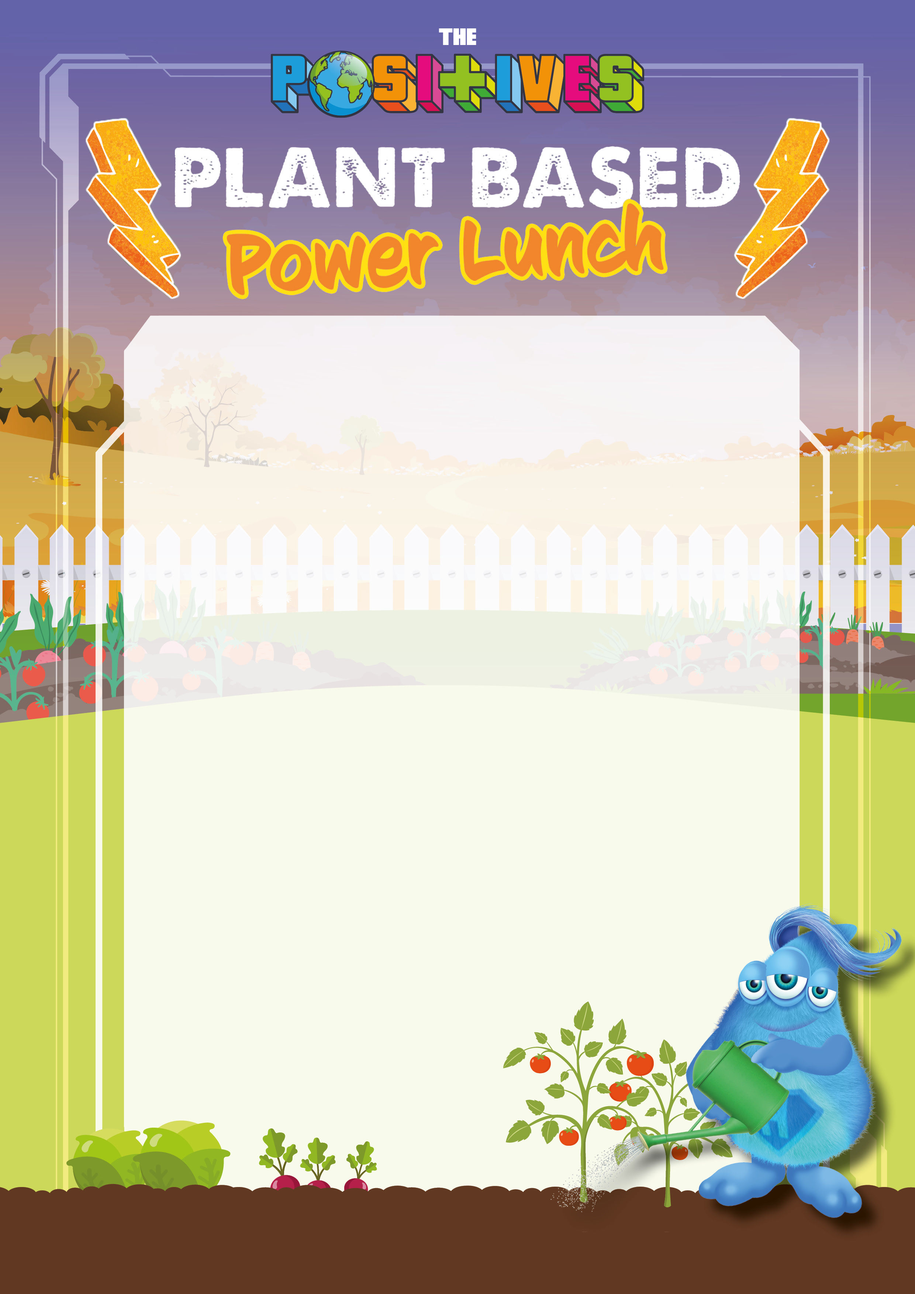

Vegan Bangers & Veggie Mash with Gravy & Peas

The Louisiana Veggie Burger with Dusted Wedges

Rhubarb Crumble

Banana Strudel