Relationships and sex education policy

Approved by: | Brackenwood Junior School Governing Body | Date: December 2023
Next review due by: | December 2024

Contents
1. Aims 3
2. Statutory requirements 3
3. Policy development 4
4. Definition 4
5. Curriculum 5
6. Delivery of RSE 5
7. Roles and responsibilities 6
8. Parents’ right to withdraw 7
9. Training 7
10. Monitoring arrangements 7
Appendix 1: Curriculum map 8
Appendix 2: By the end of primary school pupils should know 9
Appendix 2: By the end of secondary school pupils should know 11
Appendix 3: Parent form: withdrawal from sex education within RSE 14

1. Aims
The aims of relationships and sex education (RSE) at our school are to:
- Provide a framework in which sensitive discussions can take place
- Prepare pupils for puberty, and give them an understanding of sexual development and the importance of health and hygiene
- Help pupils develop feelings of self-respect, confidence and empathy
- Create a positive culture around issues of sexuality and relationships
- Teach pupils the correct vocabulary to describe themselves and their bodies

The curriculum at Brackenwood Junior School has been developed to prepare our children for their future. In order to embrace the challenges of creating a happy and successful adult life, pupils need to understand the world in which they are growing up. High quality, age-appropriate teaching of Relationships and Health Education can help to prepare pupils for the opportunities, responsibilities and experiences of adult life.

2. Statutory requirements
As a primary academy school we must provide relationships education to all pupils as per section 34 of the Children and Social work act 2017.
We do not have to follow the National Curriculum but we are expected to offer all pupils a curriculum that is similar to the National Curriculum including requirements to teach science which would include the elements of sex education contained in the science curriculum.
In teaching RSE, we are required by our funding agreements to have regard to guidance issued by the secretary of state as outlined in section 403 of the Education Act 1996.
At Brackenwood Junior School we teach RSE as set out in this policy.

3. Policy development
This policy has been developed in consultation with staff, pupils and parents. The consultation and policy development process involved the following steps:
- Review – a member of staff or working group pulled together all relevant information including relevant national and local guidance

- Staff consultation – all school staff were given the opportunity to look at the policy and make recommendations

- Parent/stakeholder consultation – parents and any interested parties were invited to attend a meeting about the policy

- Pupil consultation – we investigated what exactly pupils want from their RSE

- Ratification – once amendments were made, the policy was shared with governors and ratified

4. Definition
RSE is about the emotional, social and cultural development of pupils, and involves learning about relationships, sexual health, sexuality, healthy lifestyles, diversity and personal identity.
RSE involves a combination of sharing information, and exploring issues and values.
RSE is not about the promotion of sexual activity.
Relationships Education will put into place the building blocks needed for positive and safe relationships, with family, friends and online. In an age-appropriate way, children will discuss how to treat each other with kindness, consideration and respect.
By the end of Year 6, pupils will have been taught content on:
- families and people who care for me
- caring relationships
- respectful relationships
- online relationships
- being safe

Health Education aims to give your child the information they need to make good decisions about their own health and wellbeing, to recognise issues in themselves and others and seek support when issues arise.
By the end of Year 6, pupils will have been taught content on:
- mental wellbeing
- internet safety and harms
- physical health and fitness
- healthy eating
- facts and risks associated with drugs, alcohol and tobacco
- basic first aid
- changing adolescent body

5. Curriculum
Our curriculum is set out as per Appendix 1 but we may need to adapt it as and when necessary.
We have developed the curriculum in consultation with parents, pupils and staff, taking into account the age, needs and feelings of pupils. If pupils ask questions outside the scope of this policy, teachers will respond in an appropriate manner so they are fully informed and don’t seek answers online.
Primary sex education will focus on:
- Preparing boys and girls for the changes that adolescence brings
- How a baby is conceived and born
For more information about our curriculum, see our curriculum map in Appendix 1.

6. Delivery of RSE
At Brackenwood Junior School, the updated Kapow programme for teaching Relationships and Health education will be followed. This programme sensitively and age-appropriately covers all areas of the DFE guidance. The programme will be supplemented with age-appropriate texts to ensure that children fully understand how to live alongside and respect a diverse range of people; not discriminating against others because of age, disability, gender, marriage and civil partnership, race, religion or belief, sex or sexual orientation.
Whole school and Year group overviews are available for you to read on our website alongside a list of supplementary texts and key vocabulary which will be shared with children.
RSE is taught within the personal, social, health and economic (PSHE) education curriculum. Biological aspects of RSE are taught within the science curriculum, and other aspects are included in religious education (RE).
Pupils also receive stand-alone sex education sessions delivered by a trained health professional.
Relationships education focuses on teaching the fundamental building blocks and characteristics of positive relationships including:
- Families and people who care for me
- Caring friendships
- Respectful relationships
- Online relationships
- Being safe
Sex Education
This will be taught through the science curriculum (Y5). The school nurse will deliver a puberty talk to Y5 children during the summer term.

For more information about our RSE curriculum, see Appendices 1 and 2.

7. Roles and responsibilities
7.1 The governing board
The governing board will approve the RSE policy, and hold the headteacher to account for its implementation.
7.2 The headteacher
The headteacher is responsible for ensuring that RSE is taught consistently across the school, and for managing requests to withdraw pupils from non-statutory/non-science components of RSE (see section 8).
7.3 Staff
Staff are responsible for:
- Delivering RSE in a sensitive way
- Modelling positive attitudes to RSE
- Monitoring progress
- Responding to the needs of individual pupils
- Responding appropriately to pupils whose parents wish them to be withdrawn from the non-statutory/non-science components of RSE
Staff do not have the right to opt out of teaching RSE. Staff who have concerns about teaching RSE are encouraged to discuss this with the headteacher.
Staff responsible for teaching RSE in school include all teaching staff and HLTAs (a copy of specific names can be requested via the school office)
7.4 Pupils
Pupils are expected to engage fully in RSE and, when discussing issues related to RSE, treat others with respect and sensitivity.

8. Parents’ right to withdraw
Parents do not have the right to withdraw their children from relationships education.
Parents have the right to withdraw their children from the non-statutory/non-science components of sex education within RSE.
Requests for withdrawal should be put in writing using the form found in Appendix 3 of this policy and addressed to the headteacher, Miss R Fry.
Alternative work will be given to pupils who are withdrawn from sex education.

9. Training
Staff are trained on the delivery of RSE as part of their induction and it is included in our continuing professional development calendar.
The headteacher will also invite visitors from outside the school, such as school nurses or sexual health professionals, to provide support and training to staff teaching RSE.

10. Monitoring arrangements
The delivery of RSE is monitored by Ms C Balmer (RSE Lead teacher and member of SLT) through:
Planning scrutinies
Learning walks
Pupil discussion
Pupils’ development in RSE is monitored by class teachers as part of our internal assessment systems.
This policy will be reviewed by Miss R Fry, Headteacher annually. At every review, the policy will be approved by the school Local Governing Body.

Appendix 1: Curriculum map
Relationships and sex education curriculum map
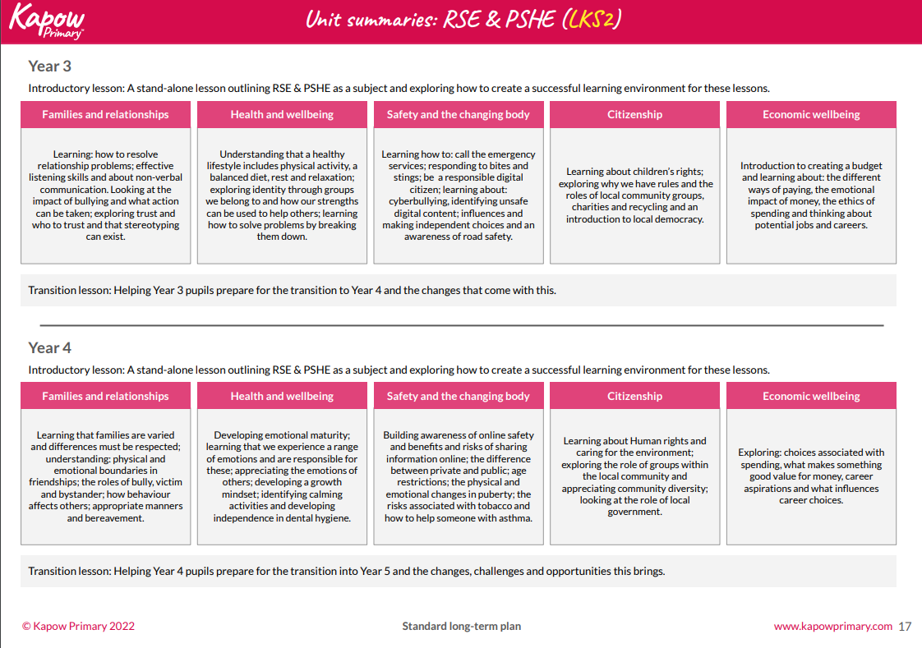
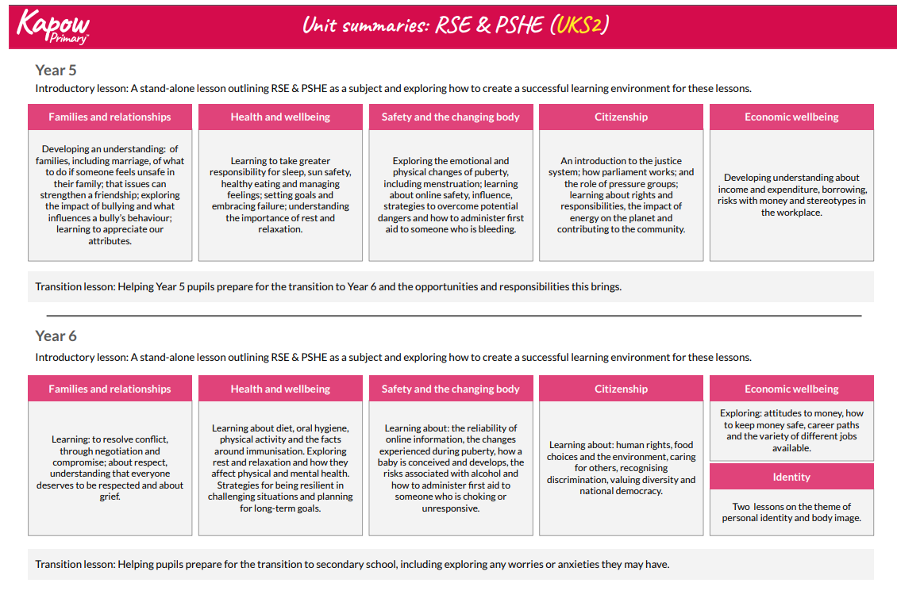
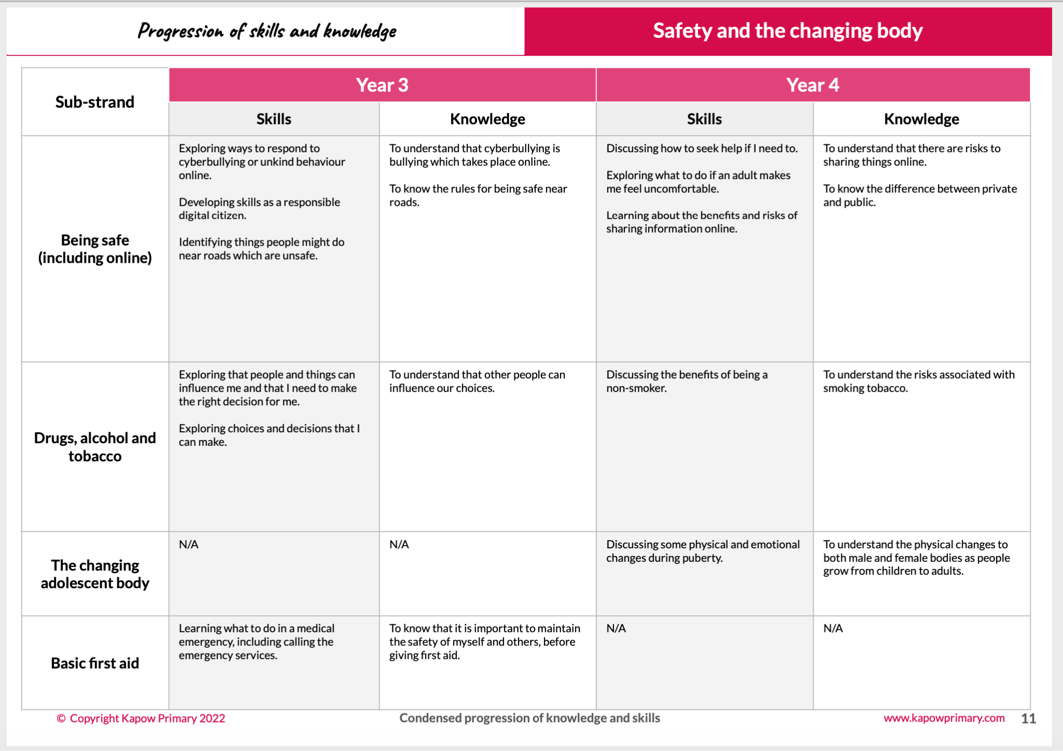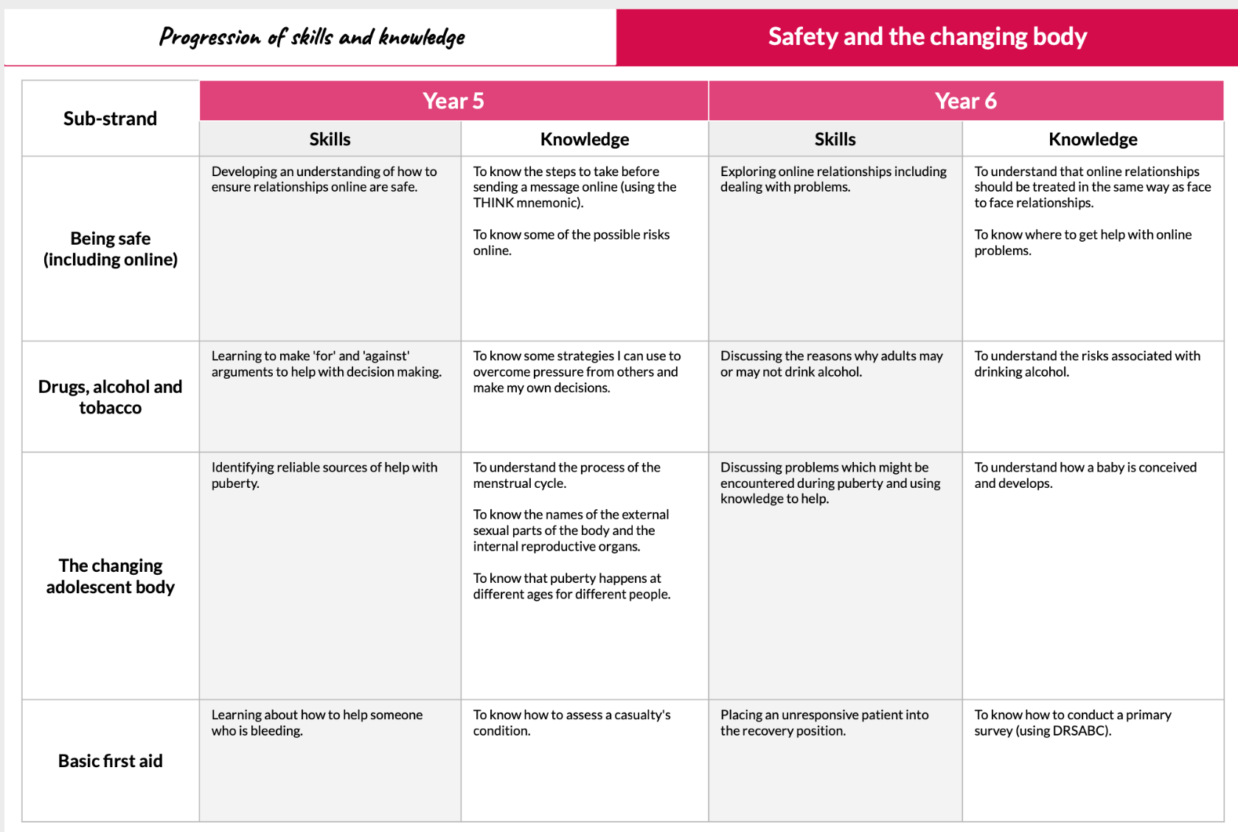
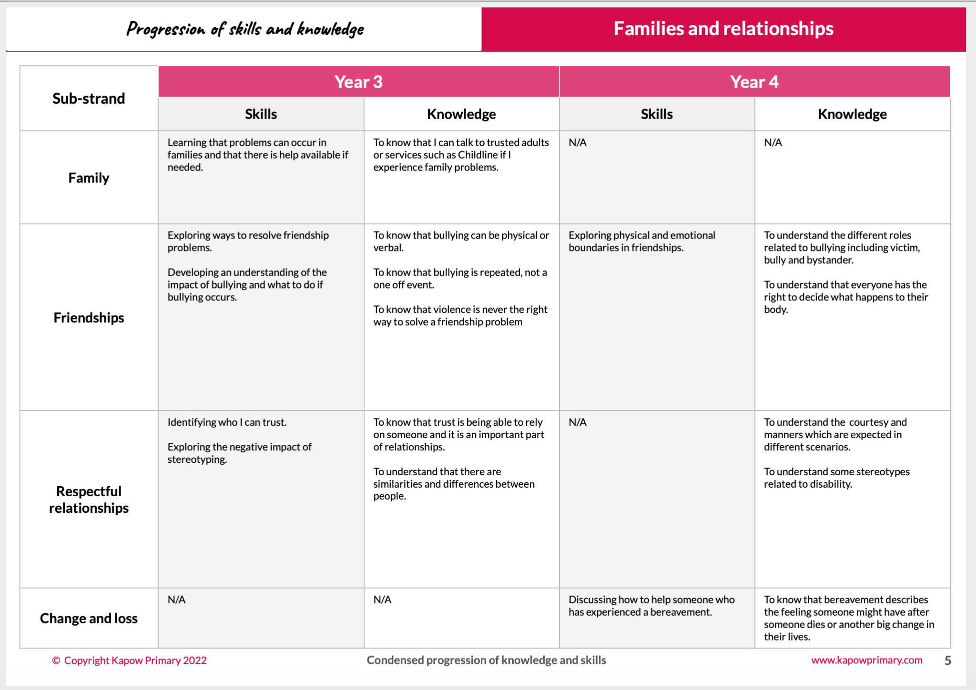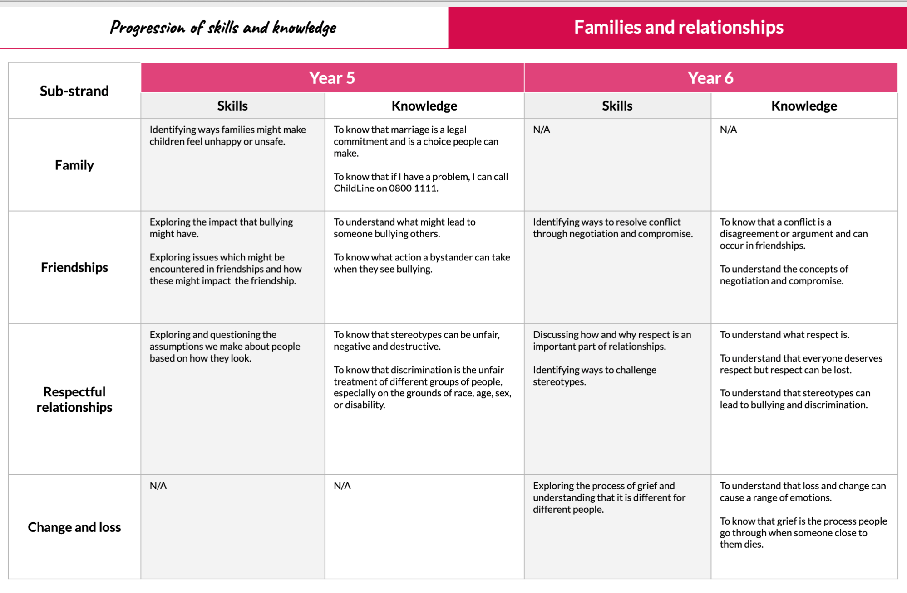
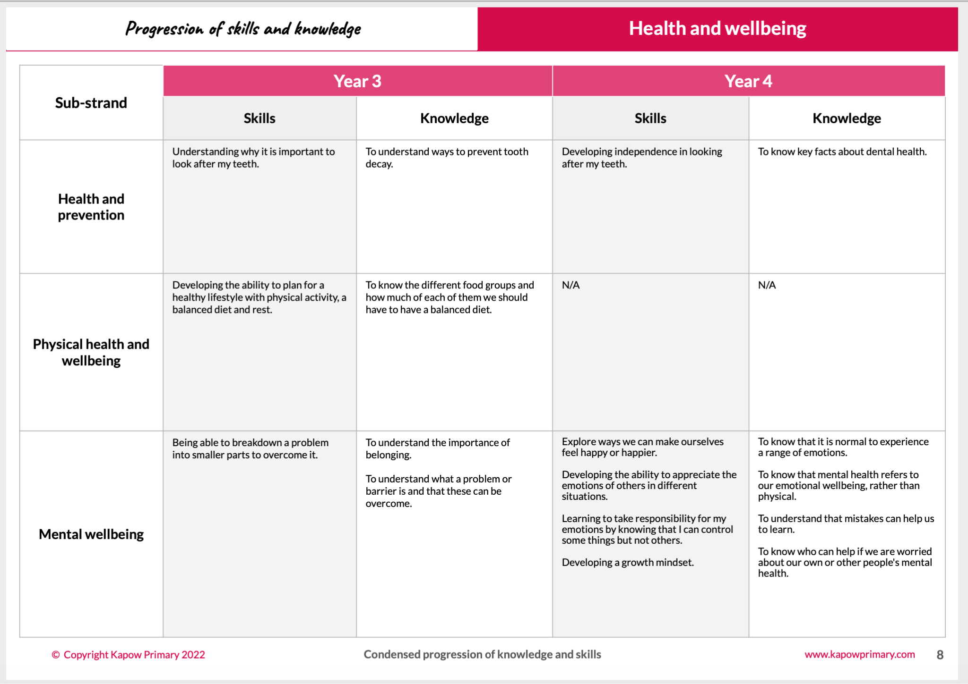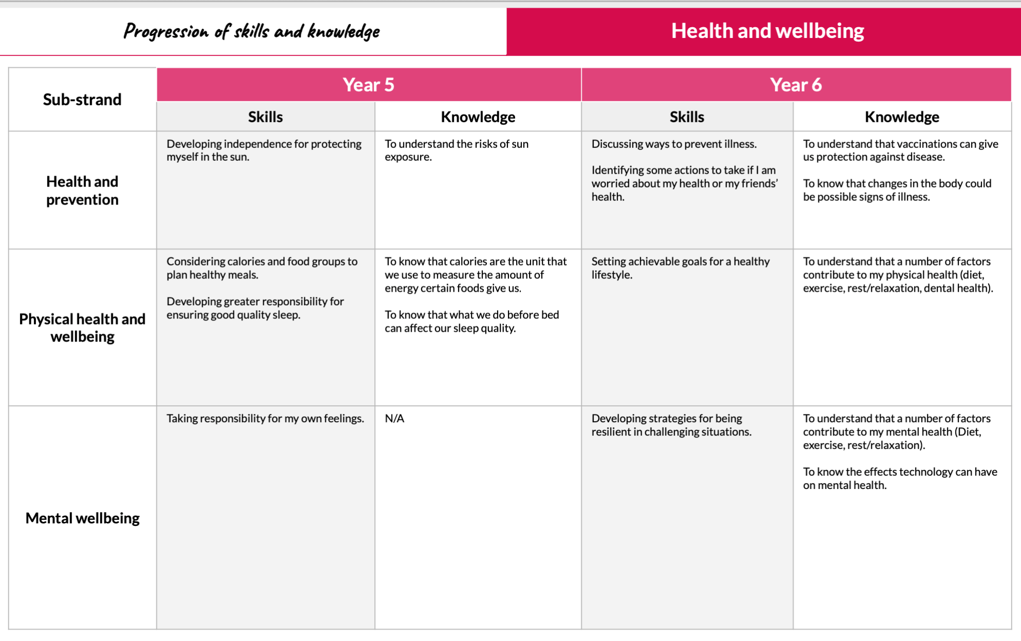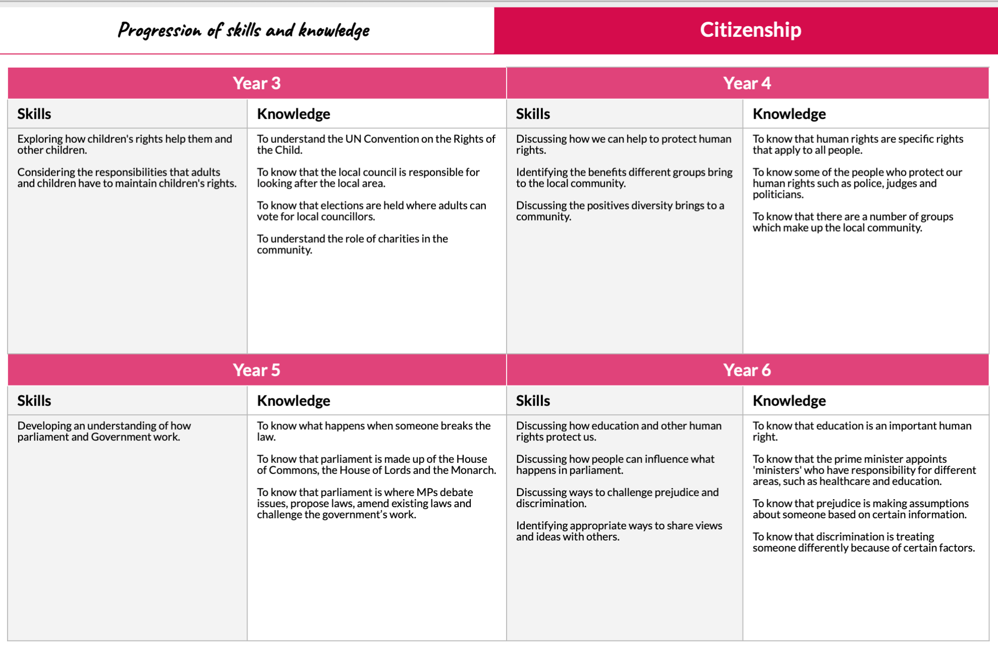
Protected Characteristics
It is important that all children leave with an understanding of the world they are growing up in, having learned how to live alongside, and show respect for, a diverse range of people. It is against the law to discriminate against someone because of:
- age
- disability
- gender
- marriage and civil partnership
- pregnancy and maternity
- race
- religion or belief
- sex
- sexual orientation

The Kapow curriculum will be supplemented by teaching of protected characteristics through year group texts and related vocabulary.
 | Autumn 1 | Autumn 2 | Spring 1 | Spring 2 | Summer 1 | Summer 2
Y3 Texts  Theme | Counting on Catherine by Helaine Becker | Counting on Catherine by Helaine Becker | Call Me Lion by Camilla Chester | Call Me Lion by Camilla Chester
Y4 Texts  Theme | Journey to Jo’Burg by Beveley Naidoo | Journey to Jo’Burg by Beveley Naidoo
Y5 Texts  Theme | Of thee I sing by Barack Obama  Young, gifted and Black by Jamia Wilson | Wonder by R.J Palacio | Wonder by R.J Palacio | The Hunter By Paul Geraghty
Y6 Texts  Theme | Windrush Child by Benjamin Zephaniah | Windrush Child by Benjamin Zephaniah

Appendix 2: By the end of primary school pupils should know
TOPIC | PUPILS SHOULD KNOW
Families and people who care about me | - That families are important for children growing up because they can give love, security and stability  - The characteristics of healthy family life, commitment to each other, including in times of difficulty, protection and care for children and other family members, the importance of spending time together and sharing each other’s lives  - That others’ families, either in school or in the wider world, sometimes look different from their family, but that they should respect those differences and know that other children’s families are also characterised by love and care  - That stable, caring relationships, which may be of different types, are at the heart of happy families, and are important for children’s security as they grow up  - That marriage represents a formal and legally recognised commitment of two people to each other which is intended to be lifelong  - How to recognise if family relationships are making them feel unhappy or unsafe, and how to seek help or advice from others if needed
Caring friendships | - How important friendships are in making us feel happy and secure, and how people choose and make friends  - The characteristics of friendships, including mutual respect, truthfulness, trustworthiness, loyalty, kindness, generosity, trust, sharing interests and experiences and support with problems and difficulties  - That healthy friendships are positive and welcoming towards others, and do not make others feel lonely or excluded  - That most friendships have ups and downs, and that these can often be worked through so that the friendship is repaired or even strengthened, and that resorting to violence is never right  - How to recognise who to trust and who not to trust, how to judge when a friendship is making them feel unhappy or uncomfortable, managing conflict, how to manage these situations and how to seek help or advice from others, if needed
Respectful relationships | - The importance of respecting others, even when they are very different from them (for example, physically, in character, personality or backgrounds), or make different choices or have different preferences or beliefs  - Practical steps they can take in a range of different contexts to improve or support respectful relationships  - The conventions of courtesy and manners  - The importance of self-respect and how this links to their own happiness  - That in school and in wider society they can expect to be treated with respect by others, and that in turn they should show due respect to others, including those in positions of authority  - About different types of bullying (including cyberbullying), the impact of bullying, responsibilities of bystanders (primarily reporting bullying to an adult) and how to get help  - What a stereotype is, and how stereotypes can be unfair, negative or destructive  - The importance of permission-seeking and giving in relationships with friends, peers and adults
Online relationships | - That people sometimes behave differently online, including by pretending to be someone they are not  - That the same principles apply to online relationships as to face-to face relationships, including the importance of respect for others online including when we are anonymous  - The rules and principles for keeping safe online, how to recognise risks, harmful content and contact, and how to report them  - How to critically consider their online friendships and sources of information including awareness of the risks associated with people they have never met  - How information and data is shared and used online
Being safe | - What sorts of boundaries are appropriate in friendships with peers and others (including in a digital context)  - About the concept of privacy and the implications of it for both children and adults; including that it is not always right to keep secrets if they relate to being safe  - That each person’s body belongs to them, and the differences between appropriate and inappropriate or unsafe physical, and other, contact  - How to respond safely and appropriately to adults they may encounter (in all contexts, including online) whom they do not know  - How to recognise and report feelings of being unsafe or feeling bad about any adult  - How to ask for advice or help for themselves or others, and to keep trying until they are heard  - How to report concerns or abuse, and the vocabulary and confidence needed to do so  - Where to get advice e.g. family, school and/or other sources

Appendix 3: Parent form: withdrawal from sex education within RSE

TO BE COMPLETED BY PARENTS
Name of child |  | Class
Name of parent |  | Date
Reason for withdrawing from sex education within relationships and sex education
Any other information you would like the school to consider
Parent signature

TO BE COMPLETED BY THE SCHOOL
Agreed actions from discussion with parents

