Science  Living things  Life cycles of mammals, amphibians, insects and birds  Reproduction in plants and animals  Animals including humans  Human development (puberty) | Music  South and West Africa  - Sing using the correct pronunciation and with increasing confidence.  - Play a chord with two notes, remaining in time.  - Maintain their part in a performance.  - Play the more complicated rhythms in time and with rests.  - Create an eight beat break and play this in the correct place. | Spanish  Animals  Pets – colours, pets we like / don’t like  Animals in the zoo / wild  Describe animals using adjectives
History  Civil Rights:  - significance of abolitionist, Olaudah Equiano  - main turning points in the Civil Rights Movement between 1950 and 1960  - significant events in Martin Luther King’s life and career  - events and impact of the Bristol Bus Boycott  - analyse the Race Relations Act  - South African Apartheid + Nelson Mandela | Brackenwood Junior School    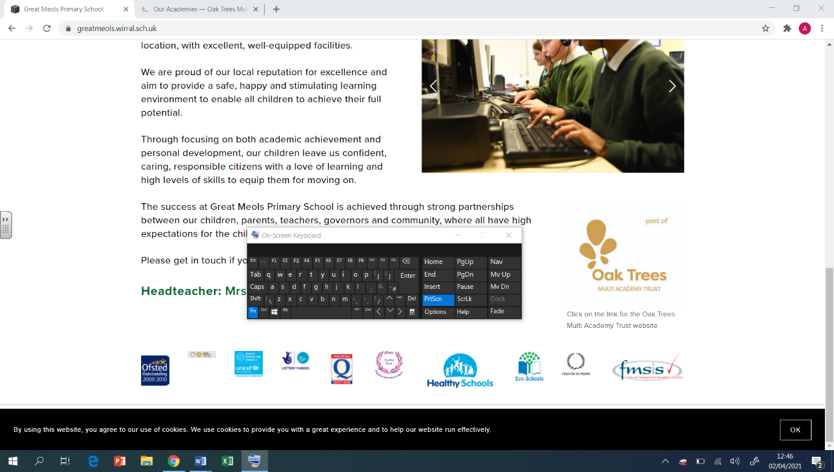  Y5  Summer Overview | PE  Orienteering  teamwork, problem solving, communication  Cricket  catching throwing, tactics, communication, batting technique  Dodgeball  agility, balance, tactics, teamwork  Football  short range passing, ball control, shooting
Geography  Climate change  To identify causes of pollution  To identify our carbon footprint  To explore pollution levels around the world  To explore pollution levels in our locality  To explain what global warming is  To identify the effect of global warming on Earth | DT  Cooking & Nutrition: Developing a Recipe  - To understand how ingredients are reared and processed.  - To make adaptations to design a recipe.  - To evaluate nutritional content.  - To practise food preparation skills.  - To design a product label.  - To follow and make an adapted recipe. | RE  Humanism  - What is a worldview?  - What do Humanists believe?  - What is important to Humanists?  - What do they use to understand the world?  - How do they lead a good life and make the most of their lives?  - How do they decide how to behave?  - How can we make the world a better place?
Computing  Vector drawing  Drawing tools, creating images, making effective drawings, layers and objects, manipulating objects, create a vector drawing  Programming Selection in quizzes  Exploring conditions, selecting outcomes, asking questions, designing a quiz, testing a quiz, evaluating a quiz | Art  Artist- William Morris  Drawing  Use a variety of materials for their work and work independently.  Explore the potential properties of visual elements, line, tone, patter, texture, colour and shape.  Printing  Select broadly the kinds of materials to print with in order to get the effects they want.  Organise their work in terms of pattern, repetition, symmetry or random printing styles.  Explain a few techniques including the use of poly blocks, relief, mono and resist printing, | PSHE  Pupils who are secure will be able to:  - Understand that borrowing money is a way to pay for something but this has to be repaid.  - Understand what income and expenditure are and how these can be recorded.  - Understand that there are risks associated with money and what some of these are.  - Understand how to create a weekly budget, including prioritising needs over wants.  - Understand that stereotypes can exist in the workplace and how these can affect people.

