Part B: Review of outcomes in the previous academic year
Pupil premium strategy outcomes
This details the impact that our pupil premium activity had on pupils in the 2022 to 2023 academic year.

End of Key Stage 2 Outcomes; July 2023

 | Disadvantaged (14 pupils – 7 pupils were on the SEND register, 2 of whom had EHCPs, 2 of whom had PFAs) | Whole Cohort (68 pupils)
% of pupils achieving the expected standard in reading | 57% | 76%
% of pupils achieving the expected standard in writing | 29% | 71%
% of pupils achieving the expected standard in maths | 6% | 66%

 | Strategy Outcomes (July 2023)
Aim | Impact
As a result of having access to additional resources and support, disadvantaged pupils make accelerated progress in reading over time. This is demonstrated through rigorous fluency screening each half term, progress through a newly purchased Oxford Owl reading scheme, 1-1 reading systems, daily class reading for pleasure, termly summative assessments using NTS resources, Phonics screening, and progress through the RWI phonics & RWI Fresh Start programmes. Pupils have also been supported through bespoke support plans and reading programmes as needed | In all year groups, disadvantaged pupils made good progress in reading by the end of academic year 2022-23.  % of disadvantaged pupils expected progress expected + progress  Year 3 32% 38% 31%  Year 4 25% 74% 11%  Year 5 26% 67% 0%  Year 6 21% 69% 25%  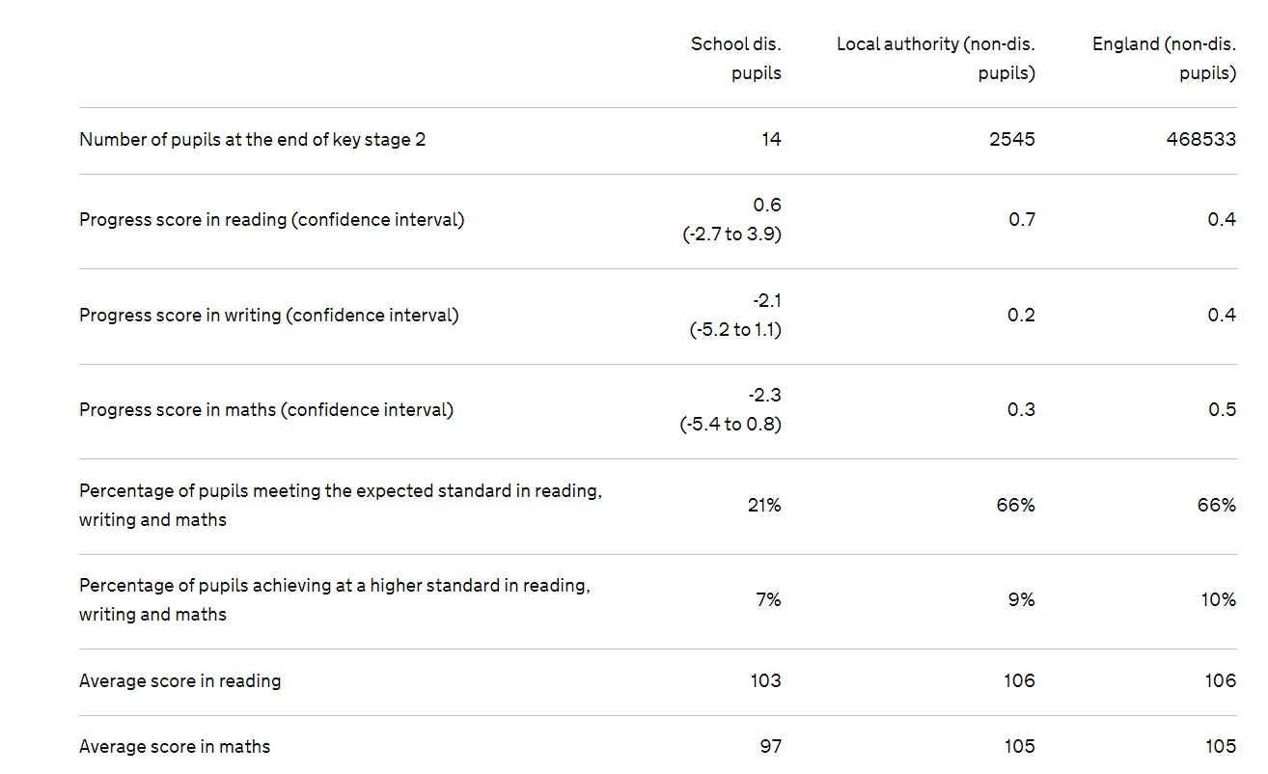

Disadvantaged pupils have made expected progress or better in Arithmetic during 2022-23. This is evidenced through termly summative NTS assessment data. A wide range of effective resources and levels of support have been implemented consistently throughout the year, including the use of bespoke support plans, catch up Maths programmes, daily fluency work, Times Tables Rock Stars, Arithmetic assessments with targeted follow up teaching and learning. | *During 2022-2023, TAs delivered the Catch Up Maths programmes; this programme was delivered to 90 children across Y3, Y4, Y5, Y6.  *Bespoke CPD has been provided by the Maths Hub and from across the MAT to support the development of Arithmetic LTP’s and the use of fluency programmes
As a result of having access to additional resources and support, disadvantaged pupils are supported to overcome any issues relating to mental health, resilience and well-being. This is demonstrated through feedback from mentors, pupil questionnaires, pupil voice meetings and questionnaires, improved levels of attendance and Boxall / SDQ profiling. | - Pupils across all year groups received additional programmes of lessons to support with positive mental health, resilience, independence and confidence as part of Quality First Teaching  - A Pastoral Teaching assistant, qualified in Mental Health first aid, was appointed to support all pupils, and especially those who are disadvantaged, to access programmes and 1-1 sessions for ensuring positive mental health and well being.  - A key aspect of school improvement during 2022-23 has focused on attendance and persistent absence. SA whole school strategy has been successful in  - A weekly Forest School session has taken place and pupils invited to attend  - A range of external agencies and consultants have been utilised effectively to provide school staff with accurate assessment and of and provision to meet the needs of specific pupils
As a result of swift and effective intervention to tackle low levels or attendance and the underlying reasons for this, disadvantaged pupils have levels of attendance which compare favourably with attendance of non-disadvantaged pupils. | - Low attendance identified for a number of disadvantaged pupils and interventions (including daily & weekly tracking systems, termly attendance letters, home visits, phone calls, attendance panel meetings, Twitter and assembly celebrations) put into place.  - Albeit an improvement has been evidenced, attendance for disadvantaged pupils remains lower in comparison to non-disadvantaged pupils; the school has instigated the use of a range of strategies during 2023-2024 to improve this. Support from across the MAT will be accessed to ensure favourable outcomes.  Disadvantaged Pupils Non-disadvantaged Pupils  2021 - 2022 - 93.3% 2021 - 2022 - 96.1%  2022-2023 - 93.4% 2022-2023 - 96.2%
The cultural experience of disadvantaged pupils is enhanced through access to a range of trips and visits to a variety of locations.  Disadvantaged pupils have access to cultural opportunities within school such as musical tuition and other clubs. | - Trips and visits were accessed by all children and financed for disadvantaged pupils as required
 | - Disadvantaged pupils were invited to attend two clubs each week free of charge. 64% of disadvantaged pupils attended at least 1 extra curricular club during 2022-2023

Externally provided programmes
Please include the names of any non-DfE programmes that you purchased in the previous academic year. This will help the Department for Education identify which ones are popular in England

Programme | Provider
Power Maths | Pearson
Maths Mastery NCETM | Maths Hub
Vipers | The Literacy Shed
Fresh Start | RWI
Phonics | RWI Phonics
Developing Experts - Science | Developing Experts
Kapow - PSHE, Music | Kapow

