Science  Living things  Grouping living things  Classification  Impact of changing environments  Animals including humans  Digestive system  Teeth  Food chains - producers, predators and prey | Music  Samba and Carnival sounds and instruments  - Explain what samba music is and that it is mainly percussion instruments used in celebrations such as Carnival in Brazil.  - Clap on the off beat (the and of each beat) and be able to play syncopated rhythms.  - Play their rhythm in time with the rest of their group (even if they are not always successfully playing in time with the rest of the class).  - Play their break in time with the rest of their group and play in the correct place in the piece.  - Play in time with confidence; accurately playing their break. | Spanish  Animals  Pets – colours, pets we like / don’t like  Animals in the zoo / wild  Describe animals using adjectives
History  The Mayans:  - the structure of Maya society  - To know about Maya trade and diplomacy  - understand Ancient Maya beliefs  - learn about achievements of the Ancient Maya  understand how the Ancient Maya declined | Brackenwood Junior School    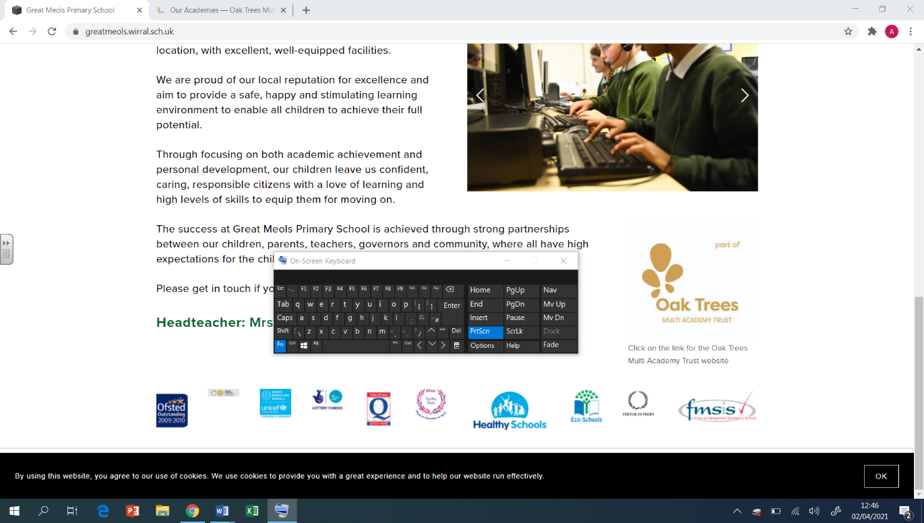  Y4  Summer Overview | PE  Health and Fitness  human body, balance, cardio  Orienteering  teamwork, problem-solving, communication, leadership  Rounders  Throw and catch, batting technique, spacial awareness  Tennis  Creating space, hand eye co-ordinatio, range of shots
Geography  Africa – Kenya  To locate the continent Africa, its countries and surrounding oceans  To identify time zones around Africa and why they exist.  To identify the human and physical features of Kenya  To identify the climate zones of Africa and compare them to the  To understand who the Maasai Mara are. | DT  Cooking & Nutrition: Adapting a Recipe  - To evaluate existing biscuit products.  - To prepare and cook a dish (biscuits).  - To select ingredients and follow a budget.  - To make and test a prototype biscuit.  Electrical Systems: Torches  - To analyse and evaluate electrical products.  - To design a product to fit a set of specific user needs.  - To make and evaluate a torch. | RE  Religion and the Environment – Making a difference for now and for the future.  - What is the impact of my actions on others and on the world?  - How can we help the earth recover before it is too late?  - Why do we all have a collective responsibility to protect the earth for now and for the future?  - How can I address environmental issues?  - How can I make a positive impact?  - What does it mean to be a responsible citizen?
Computing  Photo editing  Changing digital images, recolouring, cloning, combining, creating  Repetition in games  Using loops, animate your name, modifying a game, designing a game, creating your games | Art  Artist- Gayle Gerson  Collage  Use collage to create a composition.  Refine and alter ideas and explain choices using an art vocabulary.  Collect visual information from a variety of sources, describing with vocabulary based on the visual and tactile elements.  Painting  Make and match colours with increasing accuracy.  Use more specific colour language e.g. tint, tone, shade, hue.  Choose paints and implement appropriately.  Plan and create different effects and textures with paint according to what they need for the task.  Show increasing independence and creativity with painting process. | PSHE  Pupils who are secure will be able to:  - Understand the factors which can make something good value for money, as well as other factors that affect purchasing decisions.  - Understand how to keep track of money and why this is important.  - Understand ways in which we can lose money and the range of feelings associated with losing money.  - Understand that there are a range of influences on job choices and that these can be positive or negative.  - Understand that people can change their job.

