Science  Animals including Humans  - Five food groups  - Human and animal skeletons  - Role of muscles in the body  Light  - Light sources  - How shadows are formed  - Sun safety | Music  The History f Music  - Creating compositions for an animation  - Music from different times has different features. | Spanish  Places and Colours  Points of the compass  Countries  Where do you live? (location and accommodation)  Colours
History  Ancient Egyptians:  - the significance of the River Nile  - Ancient Egyptian daily life and beliefs  - Ancient Egyptian pyramids  - Ancient Egyptian inventions including hieroglyphics, medicine and shipbuilding  the life of Tutankhamun | Brackenwood Junior School    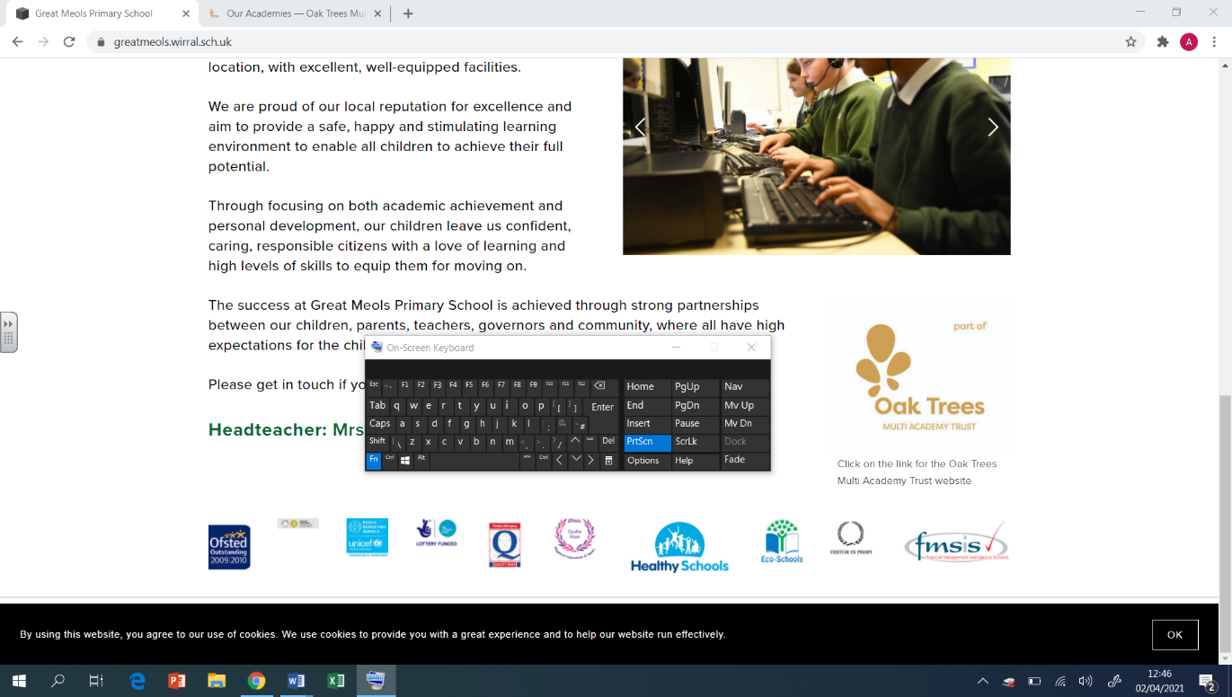  Y3  Summer Overview | PE  Cricket/Sports Day  - bowling and catching  - Overarm throwing  - Batting technique  Football/ Hockey  - Dribbling  - Short range passing and control  - Shooting and striking a ball
Geography  Where does our food come from  I can understand that the food we eat comes from many different places around the world.  I can recall how land in temperate climate zones is used to produce food.  I can understand how land in tropical climate zones is used to produce food.  I can describe the way in which land in tropical biomes is being changed to enable more food to be produced. | DT  Cooking & Nutrition: Eating Seasonally  - To explain the benefits of seasonal food.  - To develop cutting and peeling skills.  - To evaluate seasonal ingredients.  - To design a mock-up using criteria.  - To evaluate a dish.  Digital World: Wearable Technology  To develop design criteria.  To use code to program and control a product.  To develop and communicate an idea. | RE  Christians Who Inspired and Influenced the World  - What is a role model?  - What does it mean to be a courageous advocate?  - How are people driven to action change?  - How does faith play a part in the paths that people choose?  - What does it mean to put your faith into action?  - How do actions have impacts/lasting legacies?
Computing  Desktop Publishing  - Words and pictures  - Editing  - Layout  Programming  - Moving sprite  - Adding features  - Debugging | Art  Printing and Collage  - Mixing primary colours  - Shading for effect  - Repeated Patterns | PSHE  Pupils who are secure will be able to:  - Recognise some different ways to pay for items.  - Explain that money is needed when paying for items using a cheque, bank transfer or card.  - Create a simple budget.  - Explain how situations involving money can affect our feelings.  - Understand that a range of things might influence our spending choices.  - Recognise that there is a wide range of jobs available and that personal skills and interests affect career choices.  - Understand that stereotypes sometimes exist about the jobs people do.

