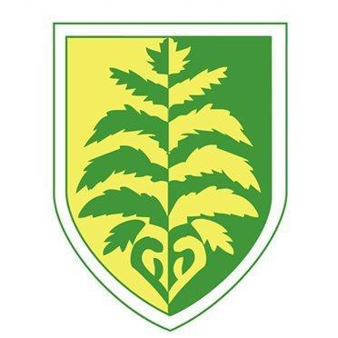

Oak Trees MAT
Approach to Writing
2023-2024
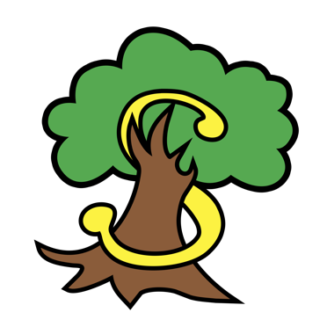

Aim:
This document aims to outline the approach to writing across the MAT. It serves as the foundation from which writing in each school will be built upon. We intend for this document to bring about a consistency across each of the schools within the MAT and with it, greater scope for moderation and parity in teacher assessment.

The Process
The writing process in each school will be personalised by the staff based on their knowledge of the children and the curriculum on offer at their school. It must, however, be based upon and include as a minimum, the processes outlined in this document. Work will predominantly be based around a text of the teachers/schools choosing. Poems and other sources of stimulation for writing will be used on occasion.

Pupils across the trust will record all their written work in English in one book. This will allow the children and any adults looking at work the opportunity to see and appreciate the journey that it has taken.

The writing process will involve the three stages of planning, drafting, and editing (all stages to be recorded in books). Within the process of planning, drafting, and editing, the children will be taught and have opportunities to rehearse SPaG (genre specific and year group specific objectives) and there will be purposeful and timely opportunities for speaking and listening.

Children will have clearly defined writing outcomes and teachers can typically expect a written outcome to take approximately 2 weeks to complete. Teachers will support children to unpick the genre and identify the features. Language and structural features of the genre will be factored into the learning (planning, drafting and/or editing process) and will be evidenced in the children’s books.

Expectations for handwriting will be modelled and taught throughout all aspects of written work to ensure that children develop the fluency and styles required at the end of each of the key stage assessment points.

All staff will be aware that the teacher assessment framework for writing is an end of key stage assessment and therefore the knowledge and skills required will be learnt, developed, and embedded across all year groups.

It is essential that all staff in school have regular opportunities to see the writing that is taking place in other year groups/classes. Class teachers should routinely be aware of what is required in the year group prior to the one that they teach and the year group that follows.

For children working outside of year group expectations (SEND pupils only), the teachers should be aware of the year group expectations and use these to shape planning and teaching. These pupils should be assessed using the relevant year group criteria.
The Writing Process
Writing is a process.
There are many parts to the process.
All parts MUST be included but the order can be moved around.
The amount of time on each part is also down to teacher’s judgement.
A unit of writing should take between 2 and 3 weeks.

Example of ‘suggested’ writing process. REMEMBER KEY POINTS FROM ABOVE.

Wk1 Day 1 | Day 2 | Day 3 | Day 4 | Day 5 | Wk2 Day 6 | Day 7 | Day 8 | Day 9 | Day 10
Introduce the genre  Text interrogation  Reading out loud  Good and bad examples  Unpick the text/features of that specific genre | Speech & Language  Speaking & Listening  HOOK  Drama  Hot-seating  Interviewing  Role-play for scenes  Conscience Alley | Grammar  Genre specific  Build word banks  Up-level into sentences  Can be in context | Grammar  Genre specific or Year group specific  Use Year group assessment framework to support grammar | Plan/Draft  A plan MUST BE IN NOTE FORM otherwise you are drafting.  Gather words  Quotes  Phrases  Dialogue  Adverbials | 1st paragraph draft  Up-level  *Or take 2/3 days to drafts and do 2 full up-levelling lessons afterwards. | 2nd paragraph draft  Up-level  (Use foot-notes) | 3rd paragraph draft  Up-level  (Use foot-notes) | 4th paragraph  Draft  Up-level  (Use foot-notes) | Publish  PUBLISHED WRITES

Curriculum Coverage of Genres

FICTION | NON_FICTION | POETRY
KS2 | KS2 | KS2
Adventure and mystery.  Science Fiction.  Fantasy.  Stories with historical settings.  Stories set in imaginary worlds.  Stories from other cultures.  Stories that raise issues and dilemmas.  Play scripts.  Novels and stories by significant children’s authors.  Fables, myths and legends.  Older literature.  Film narrative. | Recounts.  Reports.  Letters.  Newspaper Reports.  Information Texts.  Explanation Texts.  Persuasive Texts.  Biography and autobiography.  Journalistic Writing.  Debate/argument.  Formal and informal Writing. | Shape Poetry and calligrams.  Language play.  Creating images.  Exploring form.  Poetic style.  Classic/narrative poems.  Choral and performance.  The power of imagery.

The Reading Spine informs some of the texts chosen in the writing overview. Some of the class reads are used to produce units of writing in a half term or term.

The Reading Spine points out seven types of texts that children should have accessed in order to successfully navigate reading with confidence – Archaic texts, Non-Linear Time Sequences, Complexity of the Narrator, Resistant Texts, Complexity of Plot/symbol, Diversity and Other.
These are complex beyond a lexical level and demand more from the reader from other books.

At Brackenwood Junior through our writing curriculum, we want our children to draw on what they have read to become secure writers.

YEAR 3
Note: Each unit of writing must be a minimum of 2 weeks and follow the writing process.

Year 3 - Autumn 1 | Year 3 - Autumn 2 | Year 3 - Spring 1 | Year 3 - Spring 2 | Year 3 - Summer 1 | Year 3 - Summer 2
Class Read – Reading Spines – The Colour Monster – Anna Llenas – Resistent Text  Winnie the Pooh – A. A. Milne – Archaic Text |  | Class Read – Reading Spines Charlotte’s Web – E.B White –Archaic Text |  | Class Read - Reading Spines  Dominic Grows Sweetcorn – Mandy Ross. Non-Linear Time Sequences
Seal Surfer by Michael Foreman  - Letter  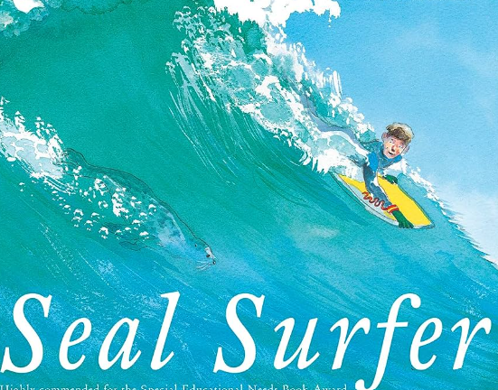  Black History Month:  Counting on Katherine by Helaine Becker  -Diary  -Persuasive Letter  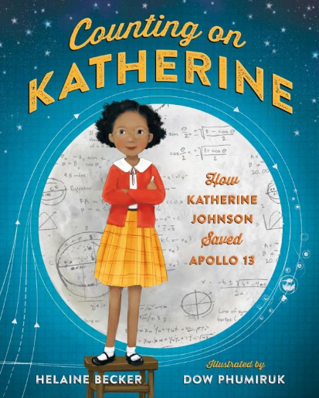 | Beware of Boys By Tony Blundell  -Instructions – Healthy recipe  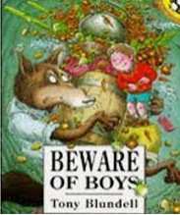  The Stone Age Boy by Satoshi Kitamura.  -Instructions - How to make a jacket  -Persuasive Text  Selling a stone age house - Advertisement  -Narrative  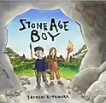 | The Great Kapok Tree by Lynne Cherry  -Riddles  - Setting description  -Dialogue  -Persuasive letter  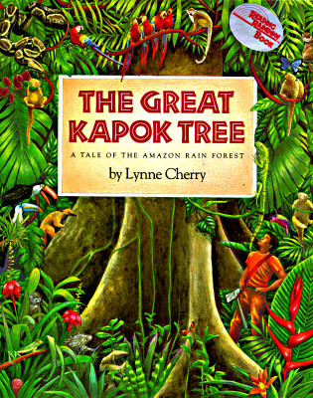 | World Book Day:  - Biography of favourite author  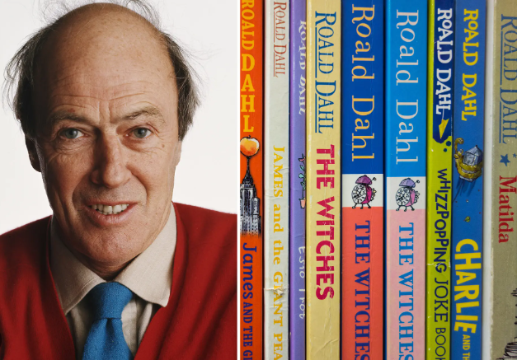  MAT Environment:  - Information leaflet on air pollution | Journey By Aaron Becker  Diary entry - Why she draw the door? Loneliness, friends?  Narrative - Adventure  Playscript - Conversation between girl and boy at the end of the text.  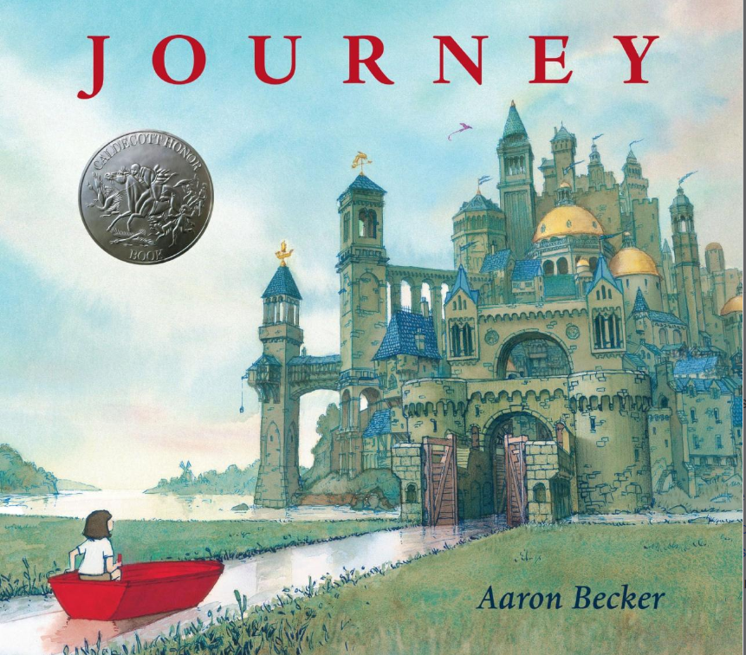 | Diversity:  ADHD Foundation  - Non chronological report  Zeraffa Giraffa  By Diane Hoffmeyer  Setting Description - Crowds when giraffe  -Letter from French people - Thanking Atir.  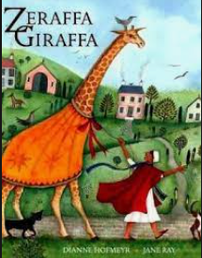

YEAR 4
Note: Each unit of writing must be a minimum of 2 weeks and follow the writing process.

Year 4 - Autumn 1 | Year 4 - Autumn 2 | Year 4 - Spring 1 | Year 4 - Spring 2 | Year 4 - Summer 1 | Year 4 - Summer 2
Class Read – –Reading Spine  Journey to Jo’Burg by Beverley Naidoo.  Complexity of the Narrator |  | Class Read – Reading Spine  Max and the Millions by Ross Montgomery  Complexity of Plot |  | Class Read - Reading Spine - The Velveteen Rabbit by CS Lewis  Archaic
Black History Month:  Journey to Jo’Burg by Beverley Naidoo.  -Diary Entry  -Persuasive letter  -Newspaper about Apartheid  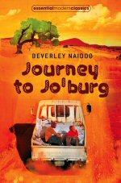 | Arthur and the Golden Rope by Joe Todd-Stanton  -Character Description  -Myth - Narrative  -Playscript  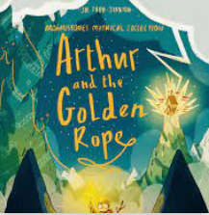 | Escape from Pompeii By Christina Balit  -Setting Description  -Narrative - Recount  -Explanation Text - How volcanoes erupt?  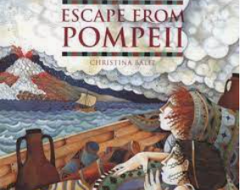 | World Book Day:  - Biography of favourite author  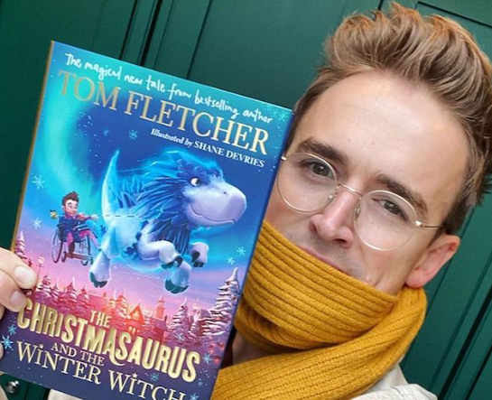  MAT Environment – Information leaflet on recycling | Gorilla by Anthony Brown.  -Persuasive Letter - Asking dad for a gorilla.  -Biography - Kira Salak  -Argument - Should gorillas be kept in captivity?  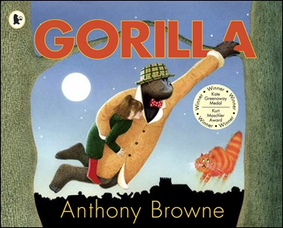 | Diversity:  Physical disabilities  - Newspaper  Leon and the place between Me.  By Grahame Baker Smith and Angela McCallister  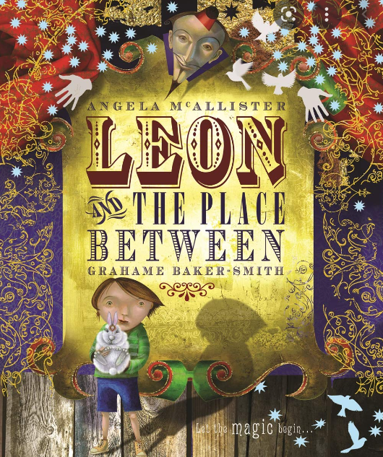  -Narrative - Next chapter - What happens in the place between?  -Instructions - How to perform a magic trick?
YEAR 5
Note: Each unit of writing must be a minimum of 2 weeks and follow the writing process.

Year 5 - Autumn 1 | Year 5 - Autumn 2 | Year 5 - Spring 1 | Year 5 - Spring 2 | Year 5 - Summer 1 | Year 5 - Summer 2
Class Read – Reading Spine  Wonder by R.J Palacio  Complexity of Narrator |  | Class Read - Reading Spine  The Viking Boy by Tony Bradman  Complexity of the Plot |  | Class Read – Reading Spine  Holes By Louis Sachar  Non -linear Time sequences
Oranges in No Man’s Land by Elizabeth Laird  - Journal/diary  - Narrative  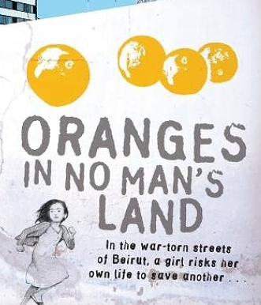  Black History Month:  Young, gifted and Black by Jamia Wilson  - Biography  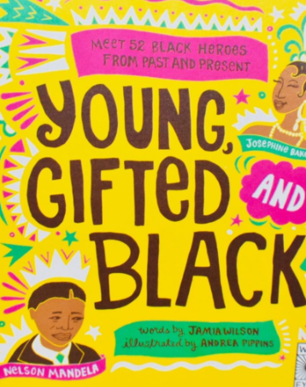 | Wonder by R.J Palacio  Reading Spine Text– Complexity of the narrator  -Persuasive letter - Persuading Auggie to go to school.  - Diary Entry - Jack  - Balanced Argument - Should Auggie forgive Jack.  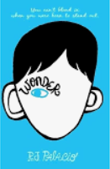 | The Viking Boy by Tony Bradman  -Playscript  -Historical narrative /myth  -Explanation  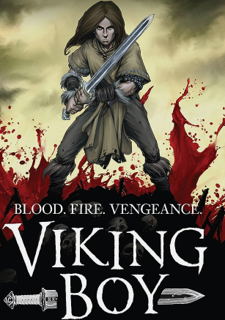 | World Book Day:  - Biography of favourite author  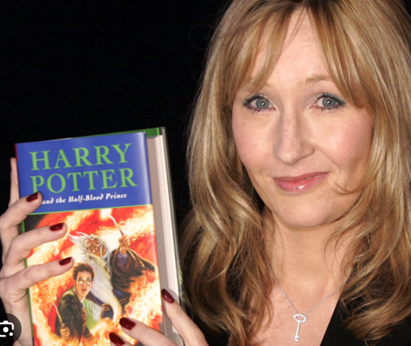  MAT Environment:  Palm Oil  - Formal letter | Holes by Louis Sachar  Reading Spine Text – Non -linear Time sequences  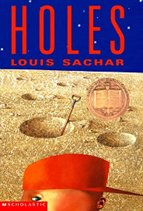  -Informal Letter home.  -Character description  -Narrative | Diversity:  Racism  Brown Girl Dreaming by Jacqueline Woodson  - Poetry  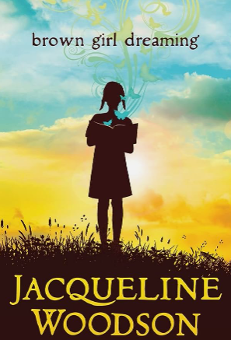  The Last Wild by Piers Torday  - Newspaper  - Advertisement

YEAR 6
Note: Each unit of writing must be a minimum of 2 weeks and follow the writing process.

Year 6 - Autumn 1 | Year 6 - Autumn 2 | Year 6 - Spring 1 | Year 6 - Spring 2 | Year 6- Summer 1 | Year 6 - Summer 2
Class Read – Reading Spine  Windrush Child by Benjamin Zephaniah  Diversity Text |  | Class Read – Reading Spine  Wizard of Oz by Frank Baum Archaic Text  Kensukes Kingdom Complexity of Plot |  | Class Read – Reading Spine  Sky Song by Abi Elphinstone  Narratively Complex
Ambassador - Head Boy/Head Girl Persuasive Letter - Formal  Audience - Headteacher  Black History Month:  Windrush Child by Zephaniah  -Non-Chron Report  -Newspaper  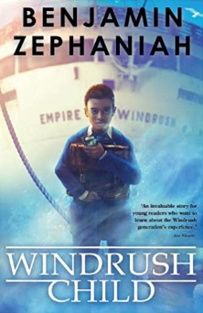 | Health & Wellbeing  - Balanced argument  Island – A story of Galapogos by Jason Chin  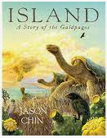  -Diary entry  -Narrative | Wizard of Oz by Frank Baum  Reading Spine Text – Archaic Text  -Setting description  -Letter to Oz  -Narrative  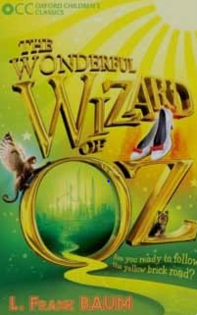 | World Book Day:  - Biography of favourite author  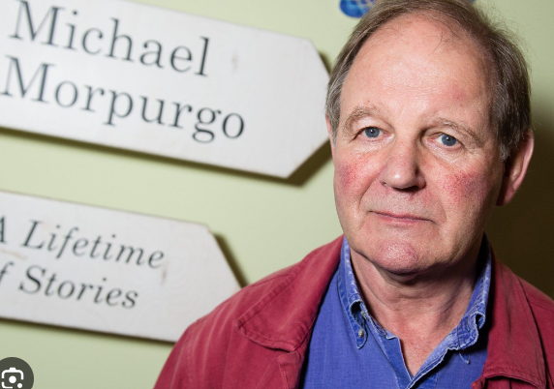  MAT Environment:  - Persuasive letter  Kensuke’s Kingdom by Michael Morpurgo  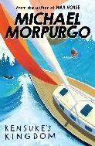  -Newspaper – Boy Overboard! | The Selfish Giant by Oscar Wilde  - Setting description  - Narrative  - Diary entry  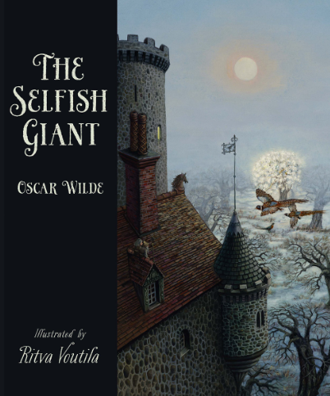 | Diversity:  LGBTQ+  - Biography  Star of Fear, Star of Hope by Jo Hoestlandt  - Diary Entry  -Letter to Lydia  