Brackenwood Junior School
Learning for Life

Headteacher: Mr. C. Holmes MMUS.PGCE.NPQH

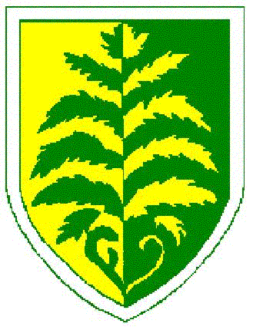

September 2020

The Governing Body of Brackenwood Junior School wishes to consult with the school’s pupils, parents, staff and local community on whether to become an academy.

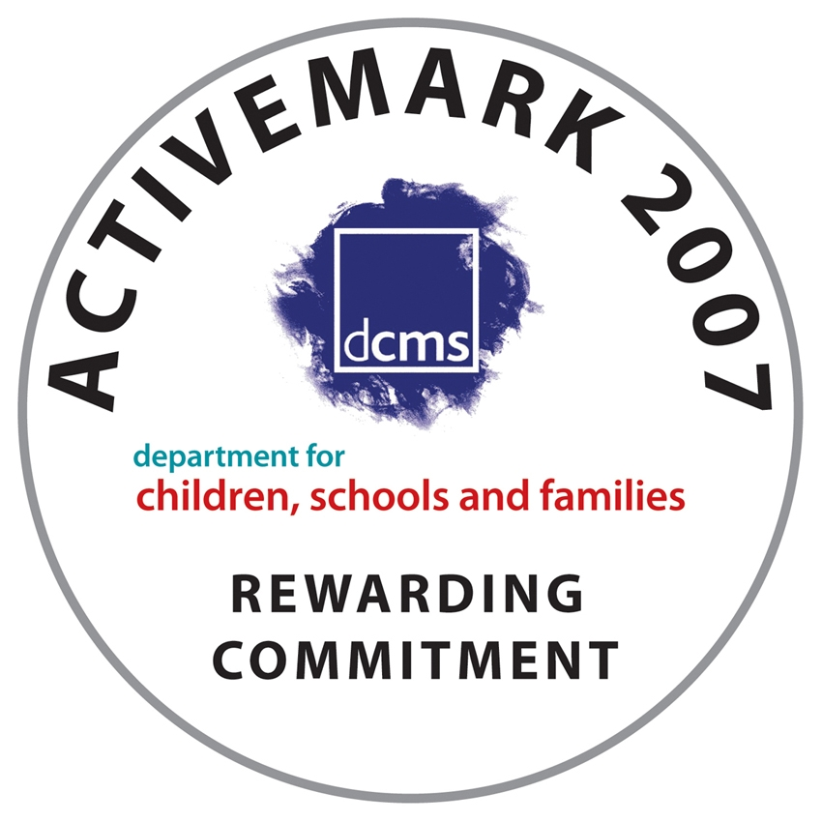


Norbury Avenue, Bebington, Wirral, CH63 2HH
Tel: 0151 608 3001 Fax: 0151 609 0179
e-mail: schooloffice@brackenwood-junior.wirral.sch.uk website: www.brackenwoodjuniors.co.uk

