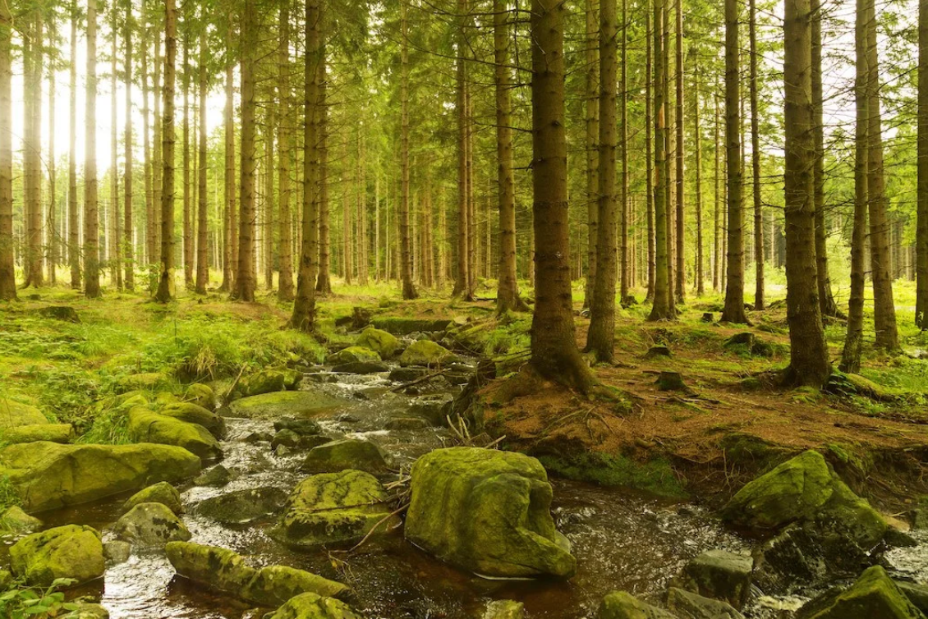

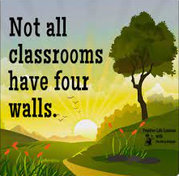

**Forest Schools Forest school is a way to discover your child’s own self. It opens opportunities to question, discover and explore our incredible world whilst in the outdoor environment. These skills will be transferable in building confident, inquisitive and rounded learners.**

Through RE & SMSC children will learn about the world around them and discover the environment of the natural world. The children will develop a sense of awe and wonder and curiosity for the natural environment.

As Mathematicians we will…. Use the natural environment to count, estimate, measure, make comparisons, sort and order, use shape and problem solve throughout our creative play.

As Scientists we will… Explore, discover, question and experience appropriate risk and challenge as we explore the natural world. We will begin to notice how the environment changes through growth, the seasons and weather. We will also learn how to care and respect the natural environment around us.

As Artists we will…. Discover colour, texture and form of the natural world. Children will use their imagination and creativity to create with mud, sticks, leaves, grass and other natural objects all around them.

Through PSHE children will develop resilience, cooperate, work collaboratively and as a team. Take risks and develop independence. Build confidence and self-esteem.

Forest Schools at Brackenwood, encourages the children to ….. Develop their creativity, imagination, resilience, confidence and self-esteem. Develop positive relationships with themselves and other people. Develop a strong, positive relationship with the natural world. Develop hands on learning experiences in a woodland or natural environment.

Through Physical Development we will develop our fine and gross motor skills, develop our spatial awareness, strength and stamina as we become confident in the outdoor environment. We will learn how to handle and use tools effectively and safely.

As Musicians we will…. Discover different environmental sounds from the natural surroundings. We will explore, listen and observe sounds from the natural world all around us, including birds, insects and the weather.

Through Literacy, children will develop their language and communication skills. They will develop listening and speaking skills. They will learn through role-play and stories. They will explore vocabulary linked to the natural world.