Brackenwood Junior School
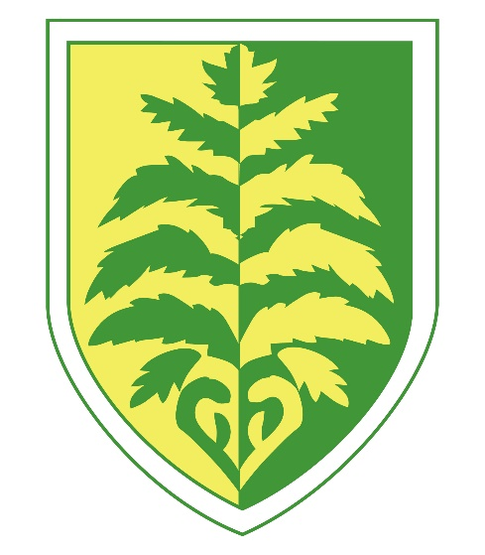

Art
Long Term Plan

Yearly Overview

Painting | Collage | Sculpture | Drawing | Print

 | Autumn | Spring | Summer
Year 3 | Light and shade and Tints and Tones  Drawing (gradients) Painting | Sandra Silberzweig  Drawing (charcoal and chalks) Painting (Elements of colour) | Clare Youngs  Printing Collage
Year 4 | Antoni Gaudi  Sculpture (Clay) | Quentin Blake  Drawing (Pen) ) Painting | Gayle Gerson  Collage Painting
Year 5 | L S Lowry  Drawing (perspective) | Monet  Painting for effect Drawing (pastels) | William Morris  Printing
Year 6 | Mike Barret  Collage Painting(ink and acrylic) Drawing (Pen) | Paper Sculpture  Sculpture (Wire) | Leonid Afremov  Painting (pallette knives)

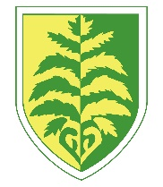
Art and Design
Creativity takes courage – Henri Matisse
Why should children learn this subject? | Art is important to children’s development and being involved in the creation of art expands the ability of a child to interact with the world around them. Art provides children with opportunities for self-expression and creativity, and fosters the development of communication skills, problem solving skills and fine motor skills.
What will children learn to do in this subject? | At Brackenwood Junior School, children will:  - Learn about great artists and designers, understanding the historical and cultural development of their art forms.  - Evaluate and analyse works of art by renowned artists.  - Develop a rich vocabulary associated with art, craft and design.  - Develop their skills in drawing, painting, sculpture and other techniques.  - Produce creative works, exploring ideas and recording their experiences.  - Create sketch books to record observations and to review and revisit ideas
How will we inspire them? | - Use works of art by renowned artists as starting points.  - Use the outdoor environment as a stimulus where applicable.  - Teach a range of different techniques and provide access to a variety of materials.  - Display and celebrate children’s work.

Our key driving themes are:

Skills Progression Map – Art and Design

Brackenwood Junior School - Progression of Skills in Art & Design – Revised April 2023
 | Year 3 | Year 4 | Year 5 | Year 6
Exploring & Developing Ideas | Select & record from first hand experiences and imagination, explore ideas for different purposes.  Question and make thoughtful observations about starting points and select ideas to use in their work.  Explore the roles and purposes of artists, craftspeople and designers working in different times and cultures. | Select & record from first hand experiences and imagination, explore ideas for different purposes.  Question and make thoughtful observations about starting points and select ideas to use in their work.  Explore the roles and purposes of artists, craftspeople and designers working in different times and cultures. | Select and record from first hand experiences and imagination, explore ideas for different purposes  Question and make thoughtful observations about starting points and select ideas and processes to use in their work.  Explore the roles & purposes of artists, craftspeople and designers working in different times & cultures | Select and record from first hand experiences and imagination, explore ideas for different purposes  Question and make thoughtful observations about starting points and select ideas and processes to use in their work.  Explore the roles & purposes of artists, craftspeople and designers working in different times & cultures
Evaluating & developing work | Compare ideas, methods and approaches in their own and others’ work and say what they think and feel about them.  Adapt their work accordingly to their views and describe how they might develop it further.  Annotate work in sketchbook. | Compare ideas, methods and approaches in their own and others’ work and say what they think and feel about them.  Adapt their work accordingly to their views and describe how they might develop it further. | Compare ideas, methods and approaches in their own work and others’ work & say what they think about them.  Adapt their work according to their views and describe how they might develop it further. | Compare ideas, methods and approaches in their own work and others’ work & say what they think about them.  Adapt their work according to their views and describe how they might develop it further.
Drawing | Experiment with different grades of pencil and other implements.  Plan, refine and alter their drawings as necessary.  Use their sketchbooks to collect and record visual information from different sources.  Draw for a sustained period of time at their own level.  Use different media to achieve variations in line, texture, tone, colour, shape and pattern. | Make informed choices in drawing inc. paper and media.  Alter and refine drawings and describe changes using art vocabulary.  Collect images and information in a sketchbook.  Use research to inspire drawing from memory and imagination.  Explore relationships between line and tone, pattern and shape, line and texture. | Use a variety of source material for their work. Work in a sustained and independent way from observation, experience and imagination.  Use a sketchbook to develop ideas.  Explore the potential properties of visual elements, line, tone, pattern, texture, colour and shape. | Demonstrate a wide variety of ways to make marks with wet & dry materials.  Identify artists who have worked in a similar way to their own work  Develop ideas using different mixed media, using a sketchbook.  Manipulate and experiment with the elements of art: line, tone, pattern, textures, form, space, colour and shape.
Painting | Mix a variety of colours and know which primary colours make secondary colours.  Use a developed colour vocabulary  Experiment with different effects and textures inc. blocking in colour, washes, thickened paint etc.  Work confidently on a range of scales e.g. thin brushes on a small picture etc. | Make and match colours with increasing accuracy.  Use more specific colour language e.g. tint, tone, shade, hue.  Choose paints and implement appropriately.  Plan and create different effects and textures with paint according to what they need for the task.  Show increasing independence and creativity with painting process. | Demonstrate a secure knowledge about primary & secondary, warm and cold, complimentary and contrasting colours.  Work on preliminary studies to test media and materials. Create imaginative work from a range of sources. | Create shades and tints using black and white.  Choose appropriate paint, paper and implements to adapt and extend their work.  Carry out preliminary studies, test media and materials and mix appropriate colours.  Work from a variety of sources, inc. those researched independently.  Show an awareness of how paintings are created (composition)
Printing | Print using a variety of materials, objects and techniques including layering.  Talk about the process used to produce a simple print to explore pattern and shape, creating designs for printing. |  | Select broadly the kinds of materials to print with in order to get the effects they want.  Organise their work in terms of pattern, repetition, symmetry or random printing styles.  Explain a few techniques, including the use of poly-blocks, relief, mono and resist printing.  Alter and modify work,  Work relatively independently.
Textiles / Collage | Create backgrounds and papers to collage with.  Experiment with combining materials.  Select colours and textures to use to collage to create a collaged piece. | Use collage to create a composition.  Refine and alter ideas and explain choices using an art vocabulary.  Collect visual information from a variety of sources, describing with vocabulary based on the visual and tactile elements. |  | Join materials in different ways.  Use different techniques, colours and textures when designing and making pieces of work.  To be expressive and analytical to adapt, extend and justify their work.
3D form |  | Make informed choices about the 3D techniques chosen. Show an understanding of shape, space and form.  Plan, design, make and adapt models.  Talk about their work understanding that it has been sculpted, modelled or constructed. |  | Describe the different qualities involved in modelling, sculpture and construction.  Develop skills working in 3D  Make a models and develop, making alterations to create a final piece.  Create sculpture and constructions with increasing independence.
And Breadth of Study | Work on their own, and collaboratively with others, on projects in 2 & 3 dimensions and on different scales.  Investigate art, craft and design in the locality and in a variety of genres, styles and traditions. | Work on their own, and collaboratively with others, on projects in 2 & 3 dimensions and on different scales.  Investigate art, craft and design in the locality and in a variety of genres, styles and traditions. | Work on their won, and collaboratively with others, on projects in 2 & 3 dimensions and on different scales.  Investigate art, craft and design in the locality and in a variety of genres, styles and traditions. | Work on their won, and collaboratively with others, on projects in 2 & 3 dimensions and on different scales.  Investigate art, craft and design in the locality and in a variety of genres, styles and traditions.

National Curriculum Programmes of Study

Purpose of study
Art, craft and design embody some of the highest forms of human creativity. A high-quality art and design education should engage, inspire and challenge pupils, equipping them with the knowledge and skills to experiment, invent and create their own works of art, craft and design. As pupils progress, they should be able to think critically and develop a more rigorous understanding of art and design. They should also know how art and design both reflect and shape our history, and contribute to the culture, creativity and wealth of our nation.

Aims
The national curriculum for art and design aims to ensure that all pupils:
- produce creative work, exploring their ideas and recording their experiences
- become proficient in drawing, painting, sculpture and other art, craft and design techniques
- evaluate and analyse creative works using the language of art, craft and design
- know about great artists, craft makers and designers, and understand the historical and cultural development of their art forms.

Attainment targets
By the end of each key stage, pupils are expected to know, apply and understand the matters, skills and processes specified in the relevant programme of study.
Schools are not required by law to teach the example content in [square brackets].

Subject content

Key stage 1
Pupils should be taught:
- to use a range of materials creatively to design and make products
- to use drawing, painting and sculpture to develop and share their ideas, experiences and imagination
- to develop a wide range of art and design techniques in using colour, pattern, texture, line, shape, form and space
- about the work of a range of artists, craft makers and designers, describing the differences and similarities between different practices and disciplines, and making links to their own work.

Key stage 2
Pupils should be taught to develop their techniques, including their control and their use of materials, with creativity, experimentation and an increasing awareness of different kinds of art, craft and design.
Pupils should be taught:
- to create sketch books to record their observations and use them to review and revisit ideas
- to improve their mastery of art and design techniques, including drawing, painting and sculpture with a range of materials [for example, pencil, charcoal, paint, clay]
- about great artists, architects and designers in history.

