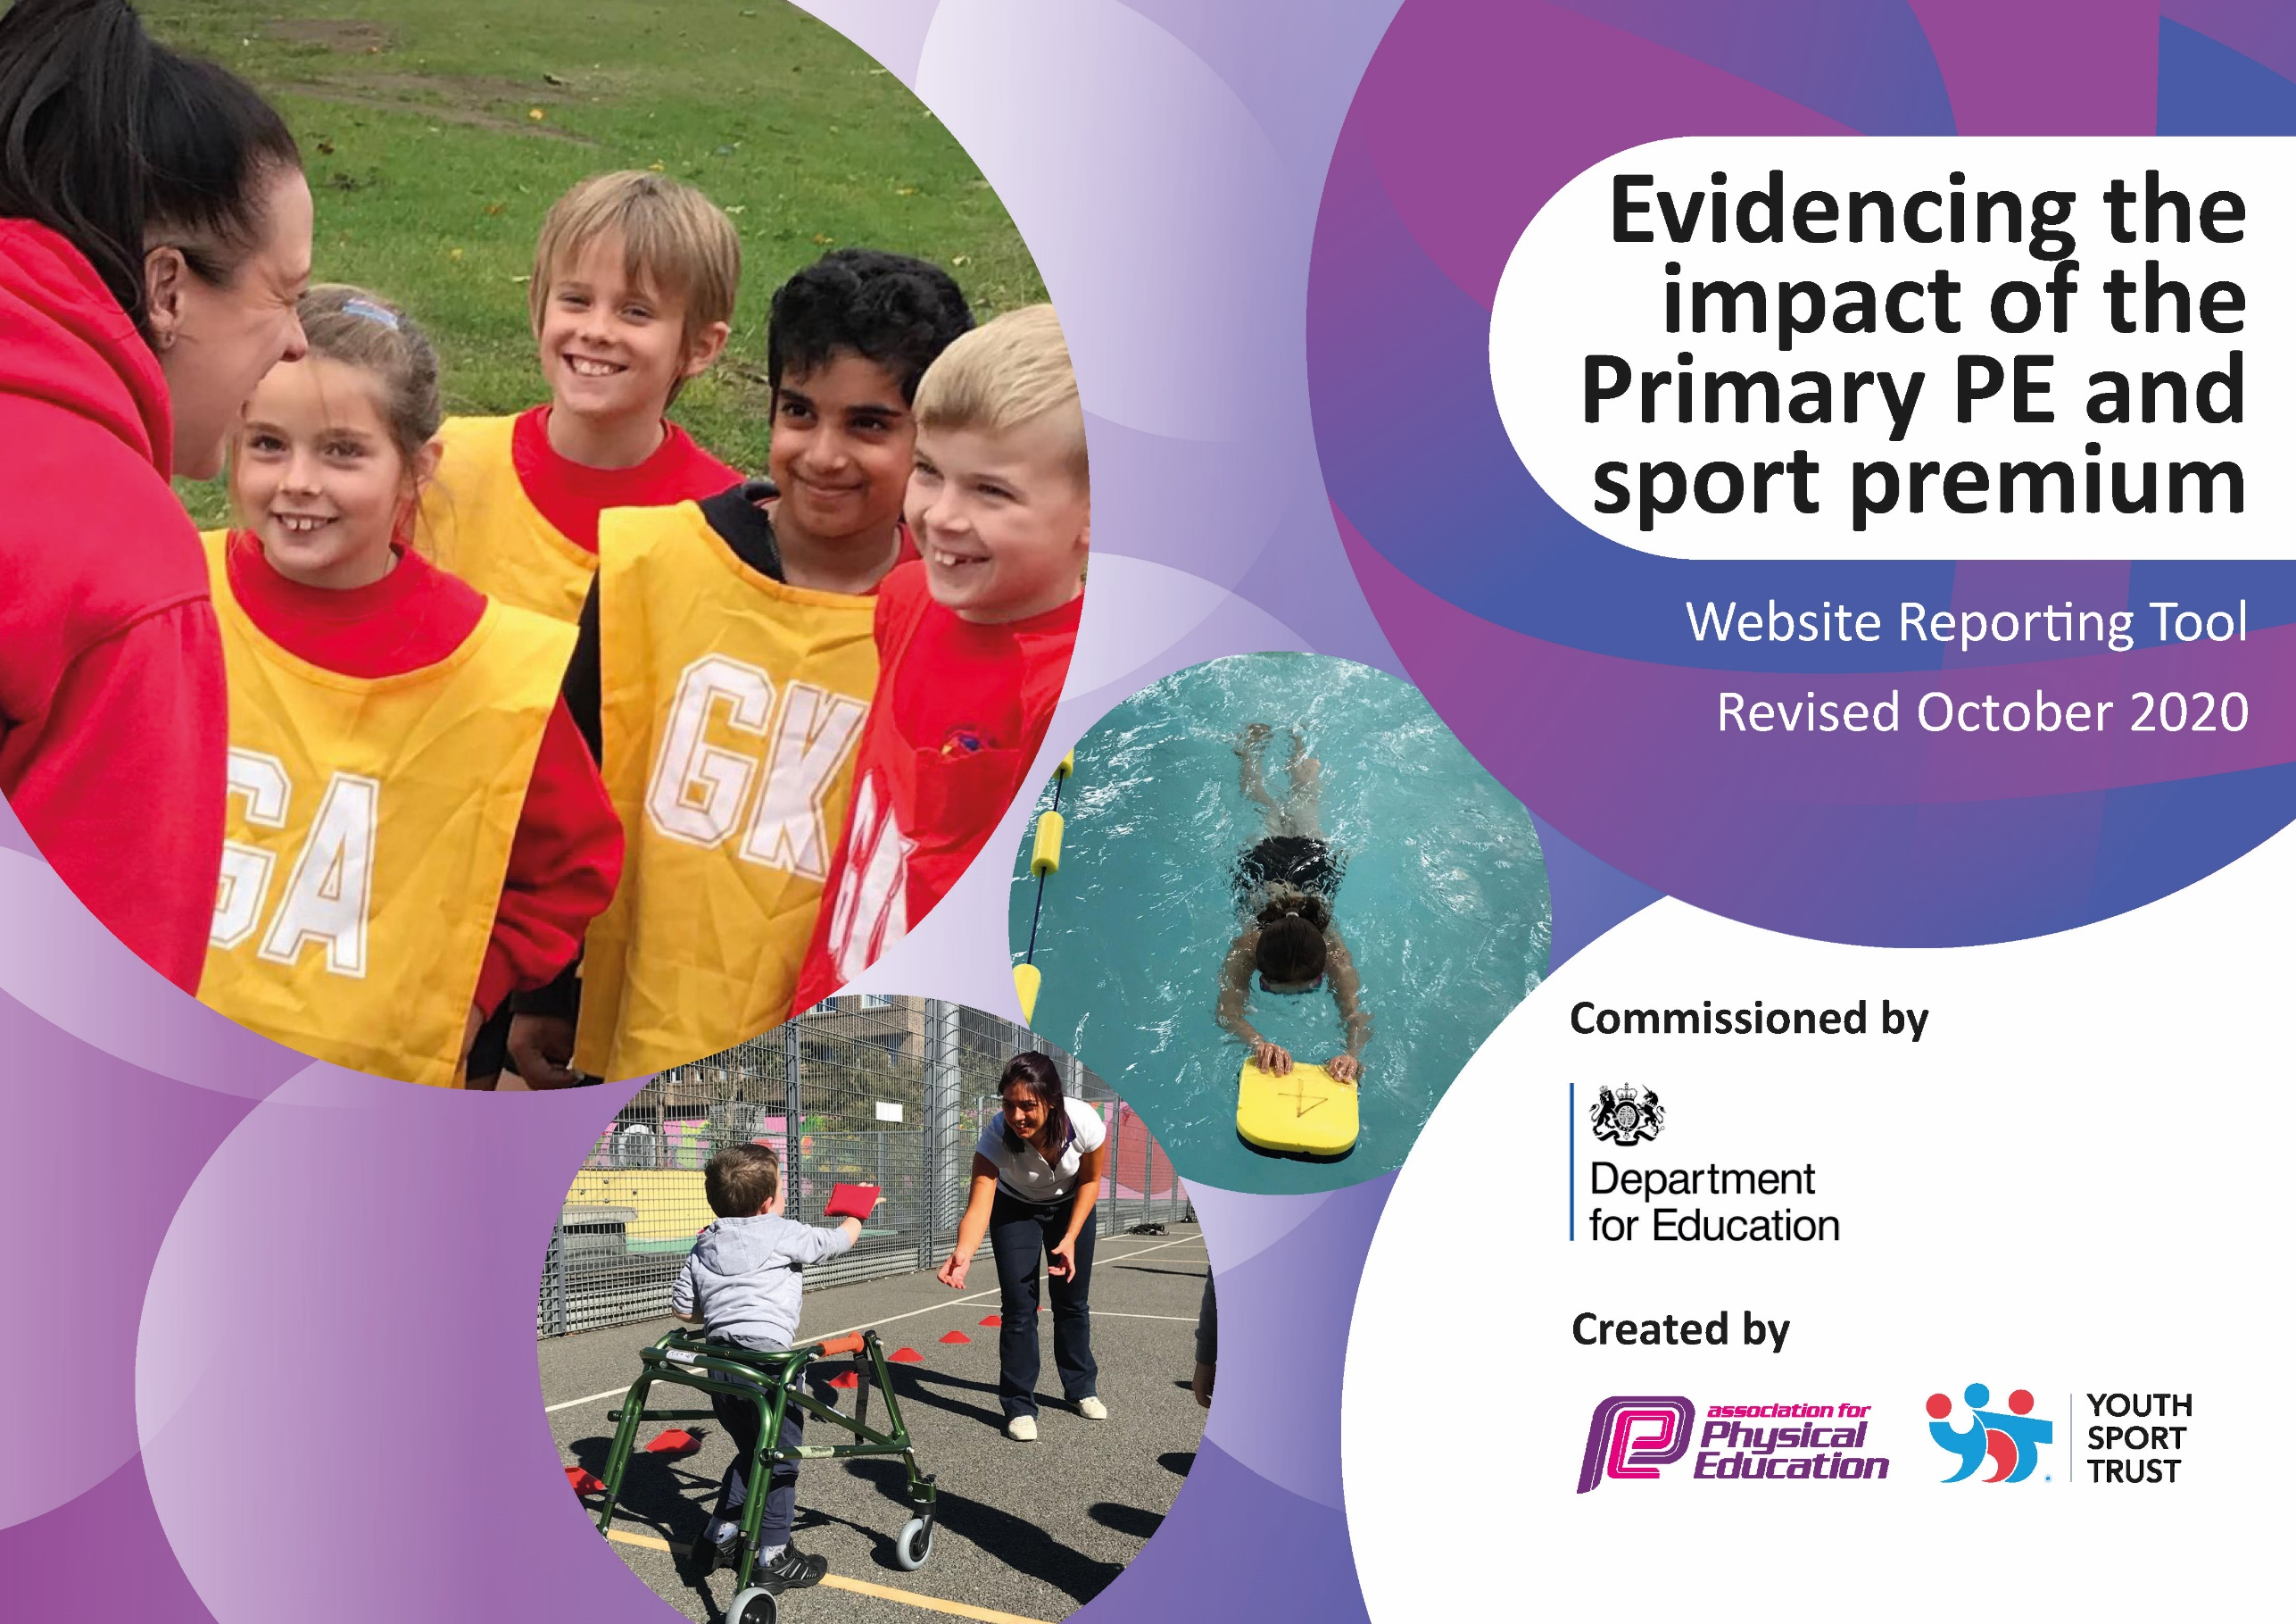
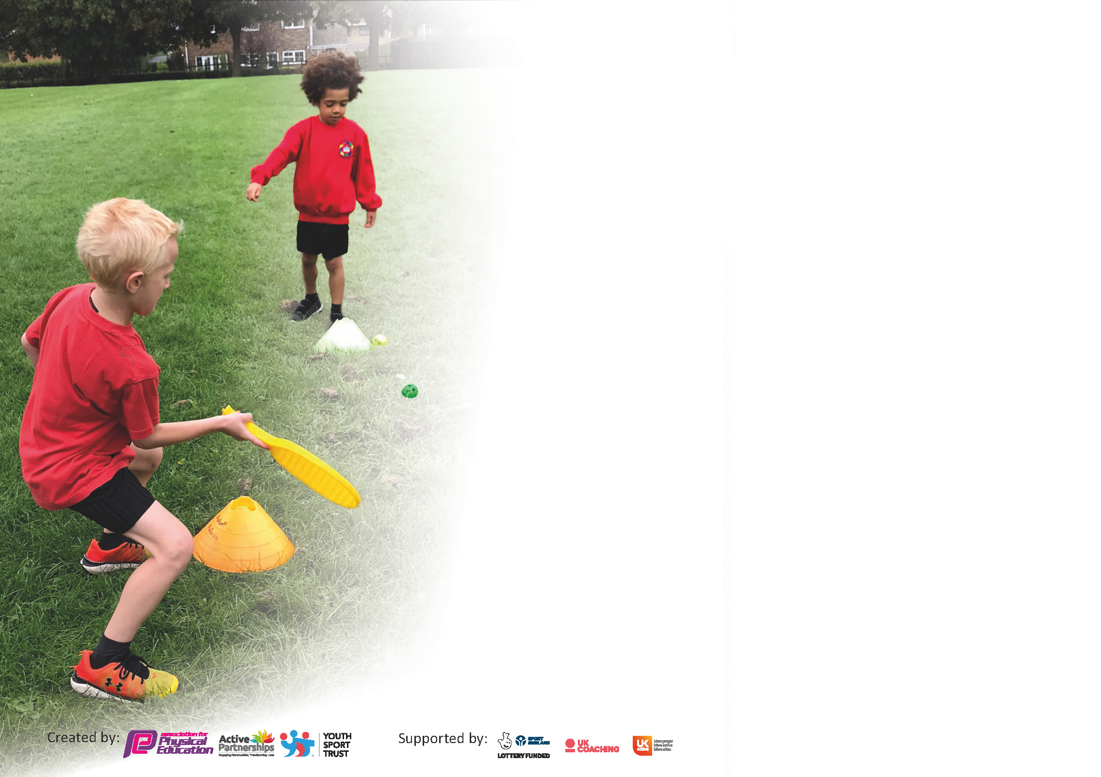

It is important that your grant is used effectively and based on school need. The Education Inspection Framework (Ofsted 2019 p64) makes clear there will be a focus on ‘whether leaders and those responsible for governors all understand their respective roles and perform these in a way that enhances the effectiveness of the school’.

Under the Quality of Education criteria (p41) inspectors consider the extent to which schools can articulate their curriculum (INTENT), construct their curriculum (IMPLEMENTATION) and demonstrate the outcomes which result (IMPACT).

To assist schools with common transferable language this template has been developed to utilise the same three headings which should make your plans easily transferable between working documents.

Schools must use the funding to make additional and sustainable improvements to the quality of Physical Education, School Sport and Physical Activity (PESSPA) they offer. This means that you should use
the Primary PE and sport premium to:

- Develop or add to the PESSPA activities that your school already offer
- Build capacity and capability within the school to ensure that improvements made now will benefit pupils joining the school in future years

Please visit gov.uk for the revised DfE guidance including the 5 key indicators across which schools should demonstrate an improvement. This document will help you to review your
provision and to report your spend. DfE encourages schools to use this template as an effective way of meeting the reporting requirements of the Primary PE and sport premium.

We recommend you start by reflecting on the impact of current provision and reviewing the previous spend.

Schools are required to publish details of how they spend this funding as well as on the impact it has on pupils’ PE and sport participation and attainment by the end of the summer term or by 31st July 2021 at the latest.

** In the case of any under-spend from 2019/20 which has been carried over this must be used and published by 31st March 2021.

We recommend regularly updating the table and publishing it on your website throughout the year. This evidences your ongoing self-evaluation of how you are using the funding to secure maximum, sustainable impact. Final copy must
be posted on your website by the end of the academic year and no later than the 31st July 2021. To see an example of how to complete the table please click HERE.
Created by: Supported by:

Please note: Although there has been considerable disruption in 2021 it is important that you publish details on your website of how you spend the funding - this is a legal requirement.
Support for review and reflection - considering the 5 key indicators from DfE, what development needs are a priority for your setting and your pupils now and why? Use the space below to reflect on previous spend and key achievements and areas for development.

N.B. In this section you should refer to any adjustments you might have made due to Covid-19 and how these will influence further improvement.
Key achievements to date until July 2023: | Areas for further improvement and baseline evidence of need:
Increased participation in walk to school scheme
Gold Schools Mark achieved
Staff have accessed CPD from Co-Op Academy
New and Improved LTP
Increased amount of extracurricular activity

Did you carry forward an underspend from 2021-22 academic year into the current academic year? YES/NO * Delete as applicable

If YES you must complete the following section
If NO, the following section is not applicable to you

If any funding from the academic year 2021/2022 has been carried over you MUST complete the following section. Any carried over funding MUST be spent by 31 March 2022.
Academic Year: September 2023 to July 2022 | Total fund carried over: £0 | Date Updated: 06/09/22
What Key indicator(s) are you going to focus on? Key Indicator 1 |  |  |  | Total Carry Over Funding:
 |  |  |  | £0
Intent | Implementation |  | Impact

Meeting national curriculum requirements for swimming and water safety.

N.B Complete this section to your best ability. For example you might have practised safe self-rescue techniques on dry land.
What percentage of your current Year 6 cohort swim competently, confidently and proficiently over a distance of at least 25 metres?  N.B. Even though your pupils may swim in another year please report on their attainment on leaving primary school at the end of the summer term 2020. | Awaiting Year 6 data
What percentage of your current Year 6 cohort use a range of strokes effectively [for example, front crawl, backstroke and breaststroke]?
What percentage of your current Year 6 cohort perform safe self-rescue in different water-based situations?
Schools can choose to use the Primary PE and sport premium to provide additional provision for swimming but this must be for activity over and above the national curriculum requirements. Have you used it in this way? | Yes

Action Plan and Budget Tracking
Capture your intended annual spend against the 5 key indicators. Clarify the success criteria and evidence of impact that you intend to measure to evaluate for pupils today and for the future.

Academic Year: 2022/23 | Total fund allocated: £11780 | Date Updated: 20.6.23
Key indicator 1: The engagement of all pupils in regular physical activity – Chief Medical Officers guidelines recommend that primary school pupils undertake at least 30 minutes of physical activity a day in school |  |  |  | Percentage of total allocation:
 |  |  |  | 6%
Intent | Implementation |  | Impact
Increase physical activity levels through extra-curricular activities in additional sports clubs provided by Full of Beans. AJ Sports clubs included in salary, Co-op Academy Bebington club included in cluster agreement.  Train Play Leaders to deliver extra provision during lunchtimes to promote physical activity for all children.  Participate in weekly Wake up Shake up/yoga breakfast club  Encourage pupils to complete the daily mile | Ensure a wide range of extra-curricular opportunities for all children across the year.  Co-op Academy to train Y6 leaders.  TA paid to run club one morning per week  Each class to have a star chart to record pupils who completed the daily mile during the day | £1,000  N/A (included in cluster agreement)  N/A  N/A | Wake up and Shake Up 3 days a week for all year groups with increased participation  Schools Game mark Achieved (awaiting confirmation of Gold)  Year 6 Sports Leaders  Year 5 Sports Ambassadors  KC runs wake up and shake up  Path used daily by each class weather permitting
Key indicator 2: The profile of PESSPA being raised across the school as a tool for whole school improvement |  |  |  | Percentage of total allocation:
 |  |  |  | 6%
Intent | Implementation |  | Impact
Hold Bike-It, Scoot-It, Walk-It Breakfast events twice during the year to promote #ActiveBodiesActiveMinds initiatve.  Organise a festival linked to #HealthyBodiesHealthyMinds initiative to promote healthy lifestyles.  Hold other events such as a Santa Dash and a summer fun run to promote physical activity to all children.  Develop the profile of WOW Walk To School by purchasing further new resources. | Provide healthy breakfast options during community event.  Provide exercise opportunities during events before school.  Ensure range of linked activities for all children across the school.  Plan event with support from PTA to encourage further physical activity.  Use whole-school assembly times to promote program further. | £450  £400  N/A (PTA funding)  £50 | Evidence of higher percentage of children walking/park and stride to school  We are working alongside Sustrans to improve this percentage further. We have had 2 active travel breakfasts as well as Year 3 and 4 bike skills training  Santa Dash completed  Walk to School promoted weekly  A huge increase of children attending clubs, events and competitions across all abilities (non-active, SEN, competitive, girls)

Key indicator 3: Increased confidence, knowledge and skills of all staff in teaching PE and sport |  |  |  | Percentage of total allocation:
 |  |  |  | 39%
Intent | Implementation |  | Impact
Increase staff confidence and standards of teaching and learning in PE through access to the CPD opportunities within the Co-op Academy Bebington cluster group. | Purchase Co-op Academy Bebington Primary Cluster agreement.  Organise CPD staff meeting for all staff in school provided by Co-op Academy Bebington.  Promote CPD sessions at Co-op Academy Bebington to all staff.  Timetable year groups to receive in-house CPD each half term from Co-op Academy Bebington. | £6,000 | All staff have received CPD from Co-Op Academy  PE Lessons are now progressive and adjusted to suit all learners  Staff have been asked to feedback which units of PE they would like to focus on for CPD in 2023/2024
Key indicator 4: Broader experience of a range of sports and activities offered to all pupils |  |  |  | Percentage of total allocation:
 |  |  |  | 47%
Intent | Implementation |  | Impact
Provide additional swimming sessions for all Key Stage Two pupils to develop fundamental swimming skills earlier and therefore further increase percentage of Y6 children achieving NC level.  Replace and upgrade current PE resources and equipment as well as lunchtime equipment, increasing physical activity.  Hold an inclusive sports festival (Summer term) including a wide variety of sports and rewards for all children. | Year 6 Autumn block (5 sessions of 60 minutes per class)  Year 5 Spring block (5 sessions of 60 minutes per class)  Year 4 Summer block (5 sessions of 30 minutes per class)  Year 3 Summer block (5 sessions of 30 minutes per class)  Audit PE stock and order replenishments where required.  Work alongside PD to audit lunchtime equipment.  Purchase medals and stickers to promote Spirit of the Games during festival. | £5260  £2000  £N/A (PTA support) | Year 4 and 5 both received 5 sessions of swimming this year  Year 3 did not go swimming  New PE stock ordered and received for lessons  New play equipment purchased for lunchtimes

*Key indicator 5: Increased participation in competitive sport |  |  |  | Percentage of total allocation:
 |  |  |  | 3%
Intent | Implementation |  | Impact
Attend a wide variety of competitions throughout the school year to give opportunities for maximum children to participate. | Engage with local secondary school competitions (e.g. South Wirral High School).  Engage with Wirral School Games Level 2 and 3 (where possible) competitions.  Engage with Wirral Cross Country events.  Engage with Co-Op Academy Bebington cluster competitions (inclusive of £6,000 in indicator 3). | £400 | We have had a huge increase in events that we have been involved with through the MAT and WSG. This includes, Futsal, Bowling, Tag Rugby, Football, Cricket and Cross County

Signed off by
Head Teacher: | C.Arnold
Date:
Subject Leader: | J Cartner
Date: | 20.6
Governor:
Date:

